

Sri Lanka Institute of Information Technology

Information Technology Project (IT2080)

2019

ITP-2019-MLB-G9-08

**USER INTERFACES**

**SKY GYM ONLINE MANAGEMENT SYSTEM**

|  |  |
| --- | --- |
| Reg No | Name |
| IT18050868 | **Z.M.M. Akaam** |
| IT18152074 | **Sangeeth Raj .A** |
| IT18144772 | **Krishnamoorthy.N** |
| IT18108132 | **Edirisinghe E.N.V** |
| IT18118650 | **Jayasooriya D.C.** |
| IT18044928 | **J.L Thilini Randika** |
| IT18128932 | **Devduni.R.M.B** |
| IT18118414 | **Imalsha Kavindi K.G.** |

**Customer Management**

**J.L Thilini Randika**

**IT18044928**

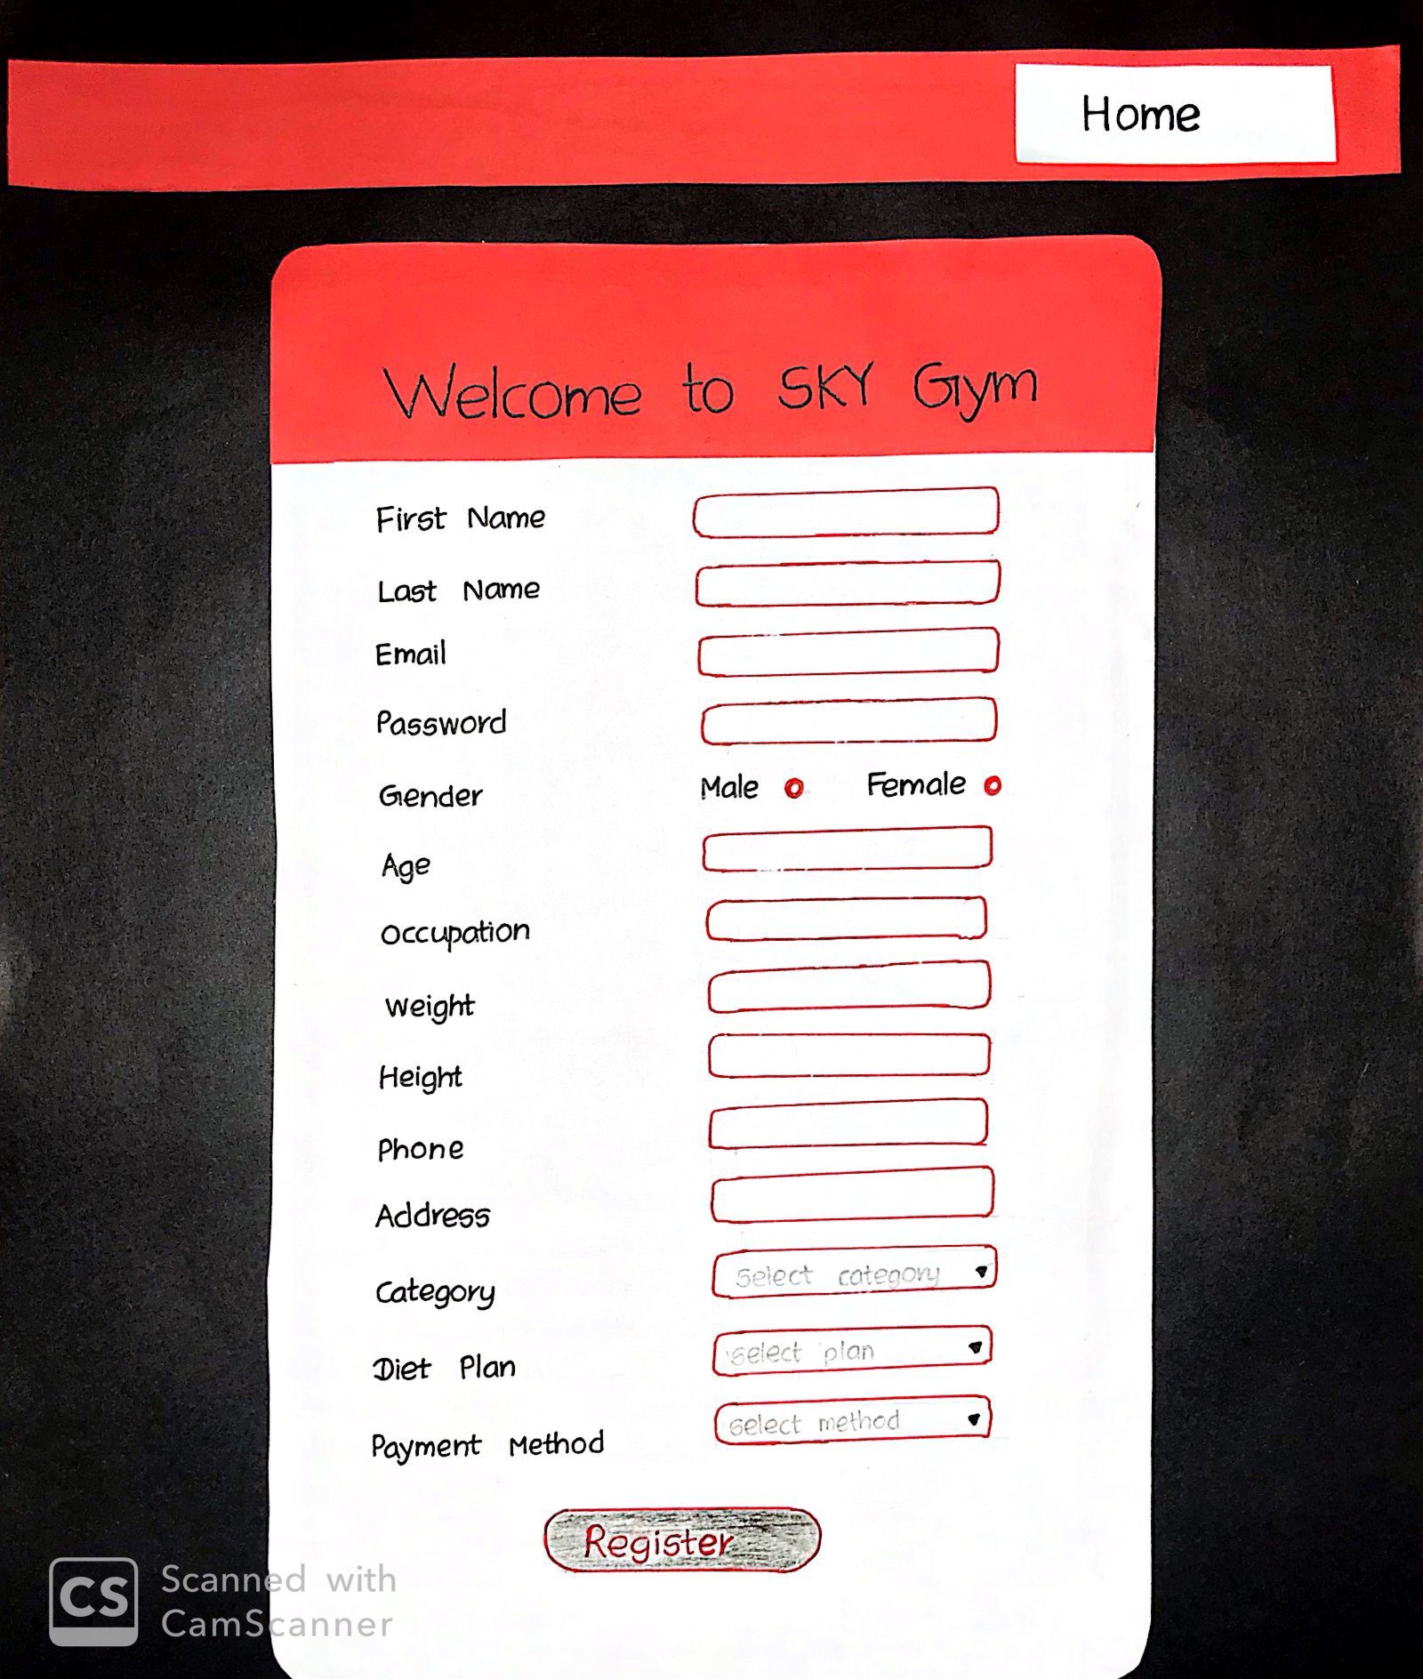

The customer can directly register by signing up to the SKY Gym entering the required details.

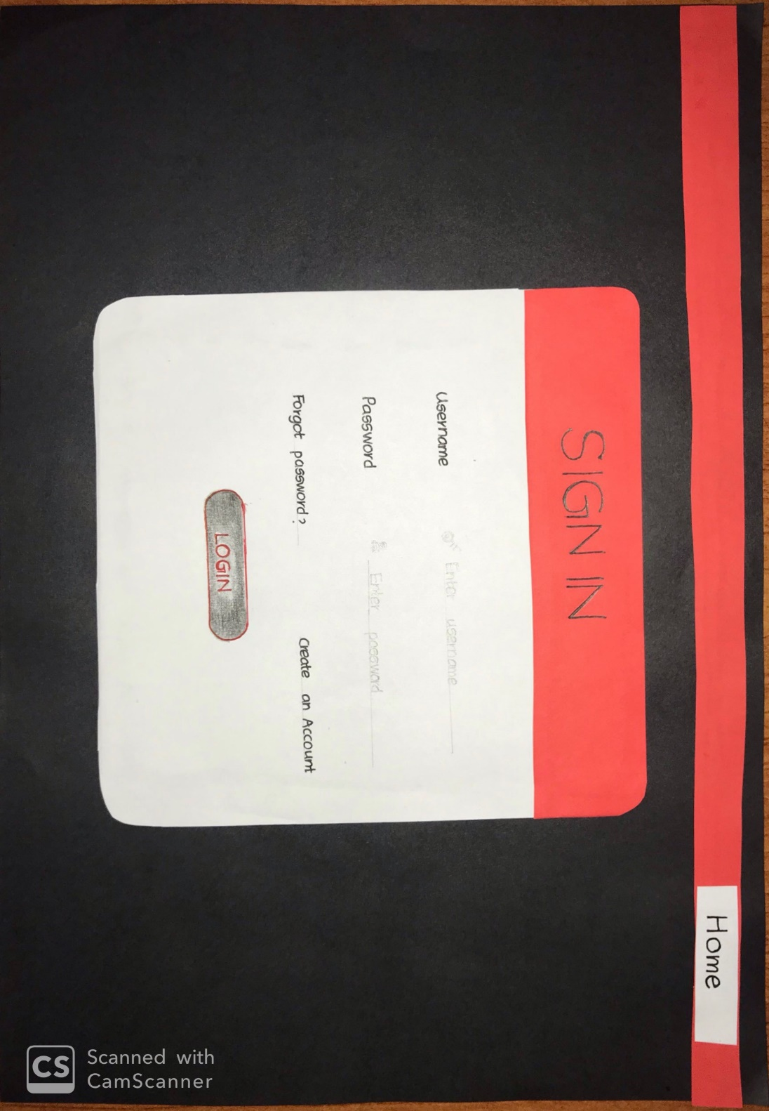

If a customer already has a profile, they can log into the system by entering username and password.

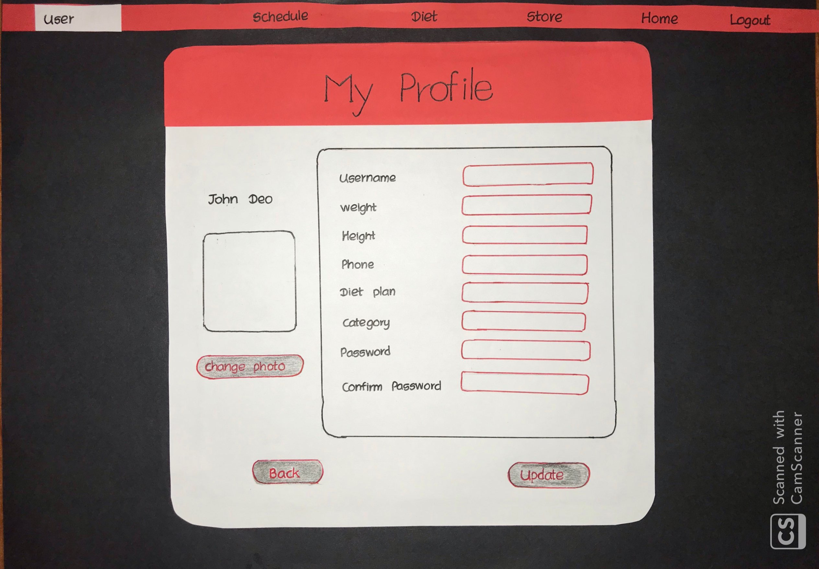

A registered member will be able to update their personal information such as their weight, height, password, profile picture etc.

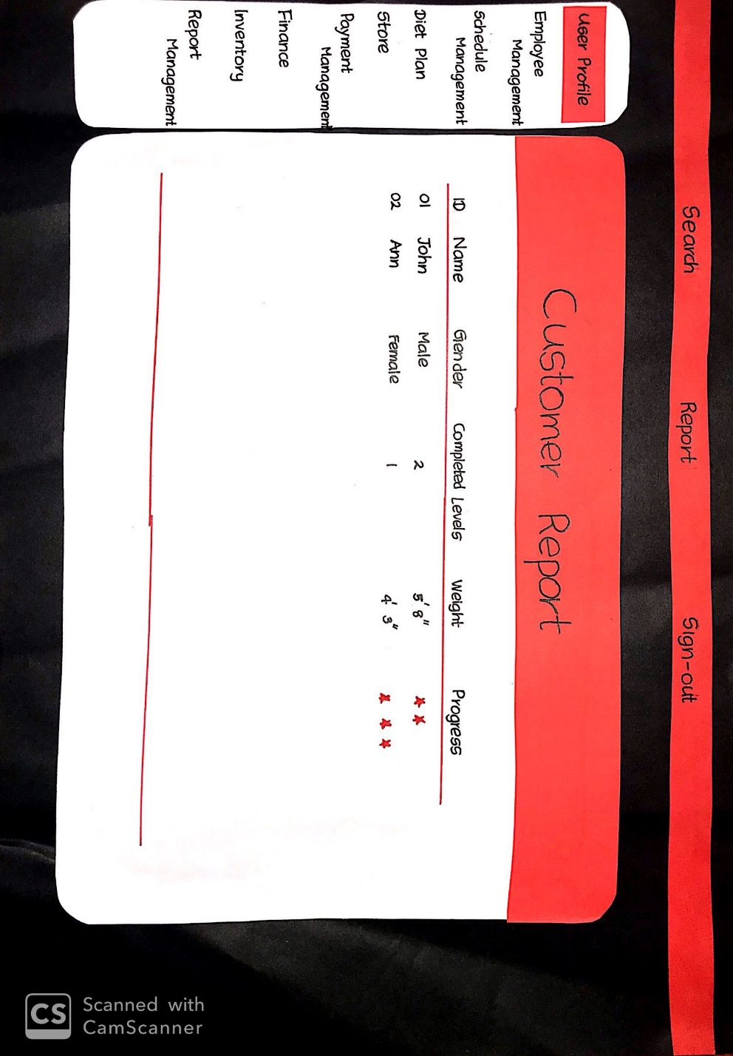

The administrator can generate monthly reports of the member at the gym and a report based on the gender.

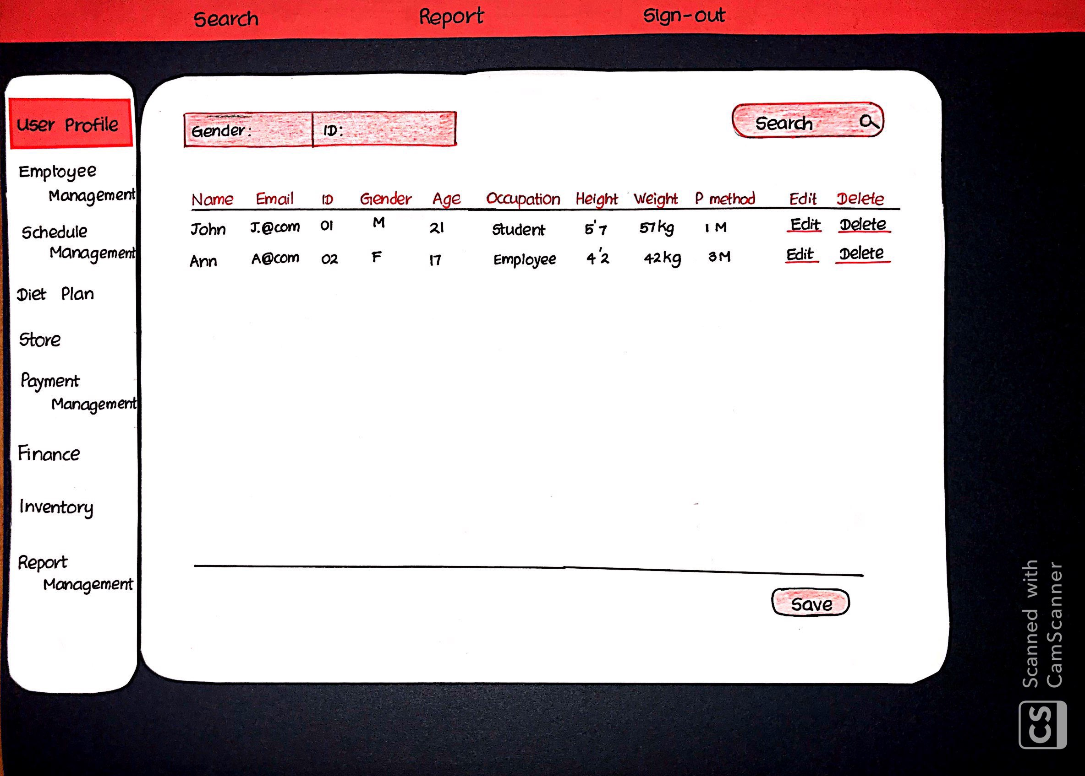

The administrator has authority to delete and update customers. If member does not want to attend the gym his records can be deleted by the administrator.

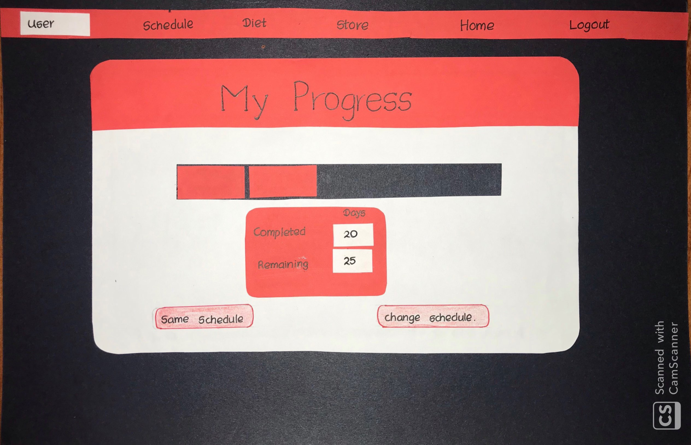

Customers will be able to mark their daily attendance. Once the customer done their particular schedule the system will suggest a new schedule or else customer will be able to continue with the same schedule.

**Employee Management**

**E.N.V Edirisinghe**

**IT18108132**

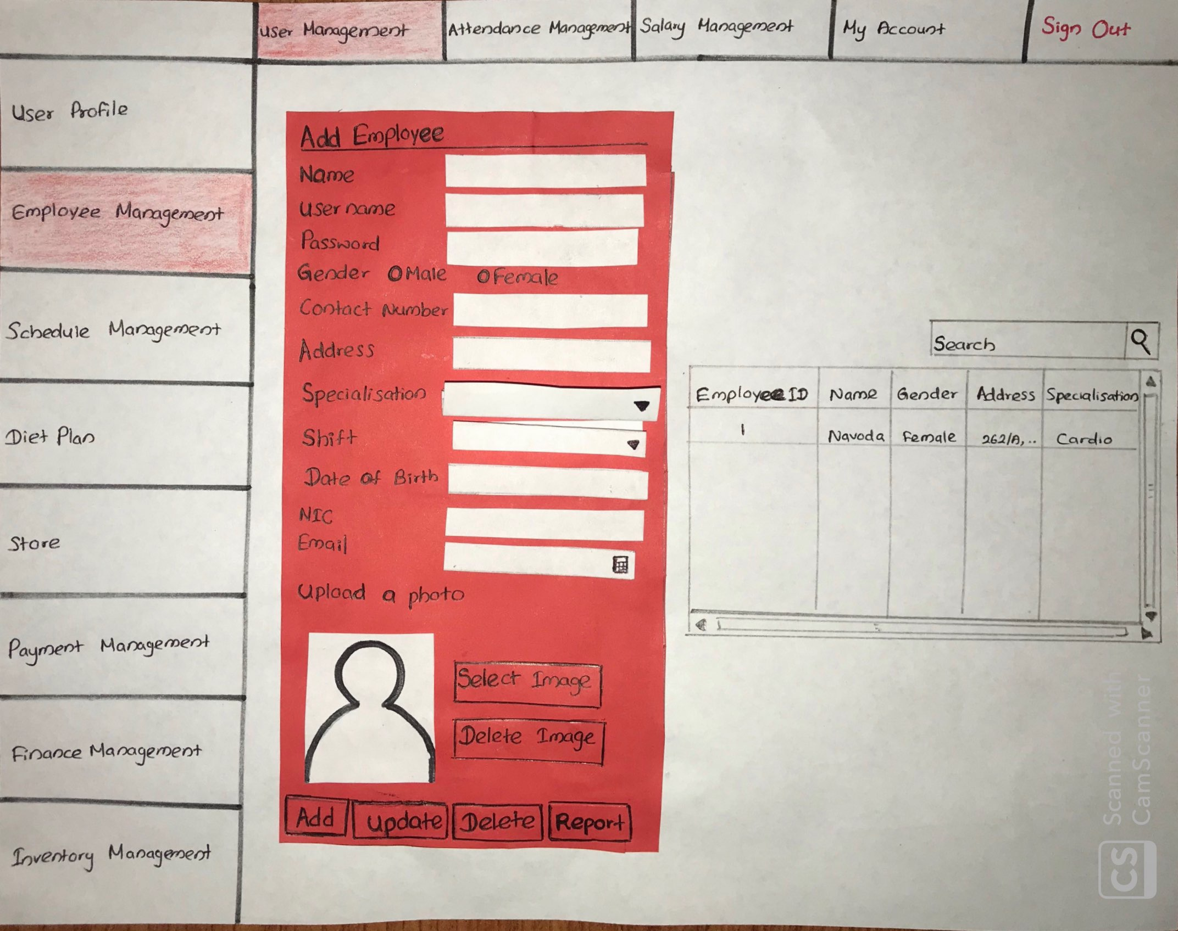

The above user interface allows the admin to add, update and delete employees of the gym.

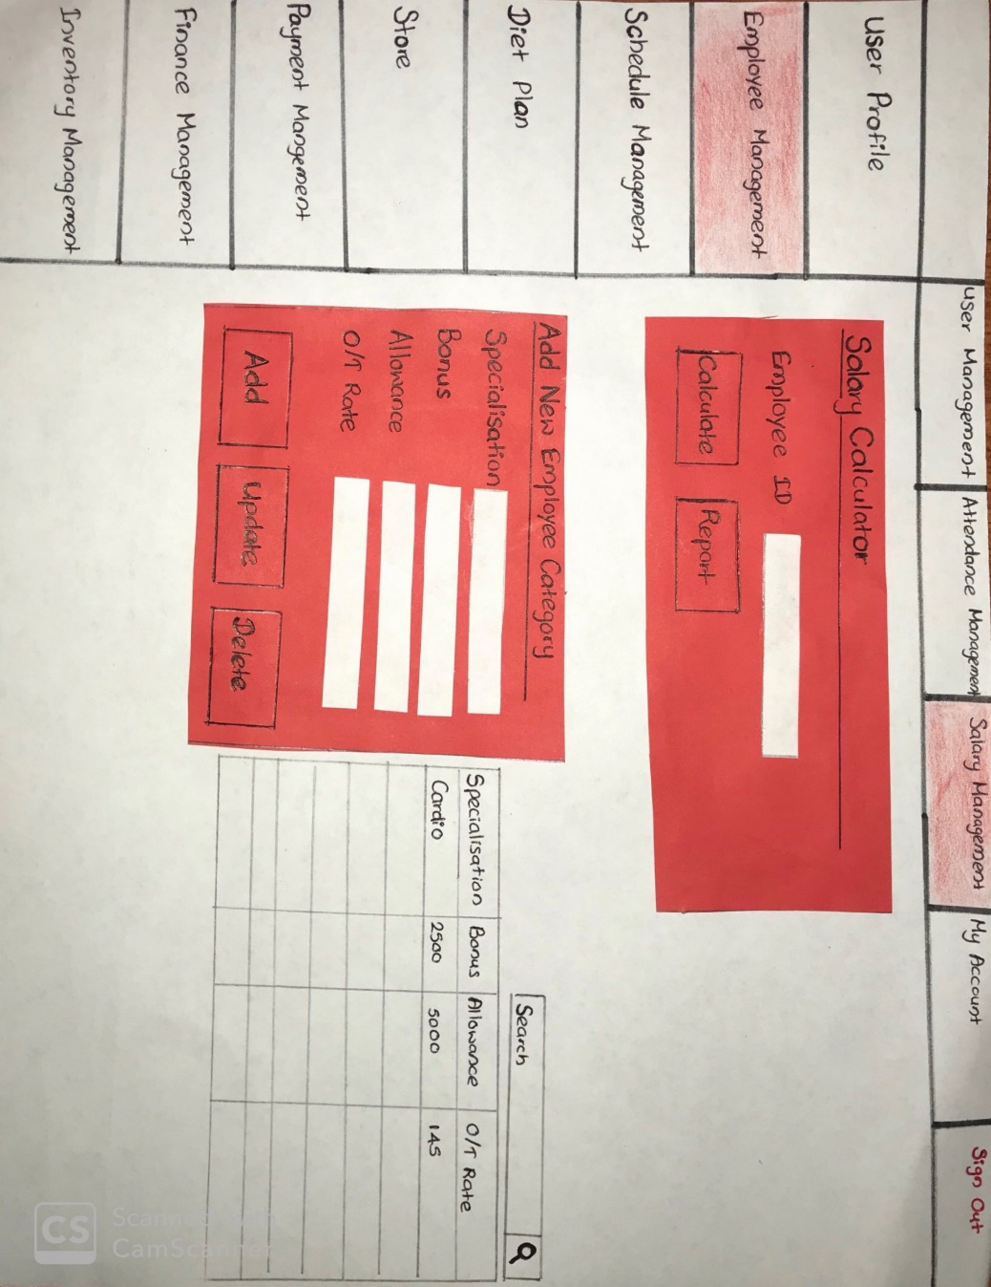

The admin must calculate the salary of a trainer which includes his/her overtime earnings as well (salary + overtime).Therefore, the admin must be able to update the OT hours of a trainer. (A count can be used in the DB). When user want to enter only employee id system will automatically calculate his/her salary. When admin want to calculate salary of all the employee’s admin can use report button. Then system will calculate salary of all employees. Employees can be dividing as specialization(schedule). Specialization to specialization bonus, allowance and over time rate are different. So that admin can add, update, delete and view specialization category list. Admin can search specialization.

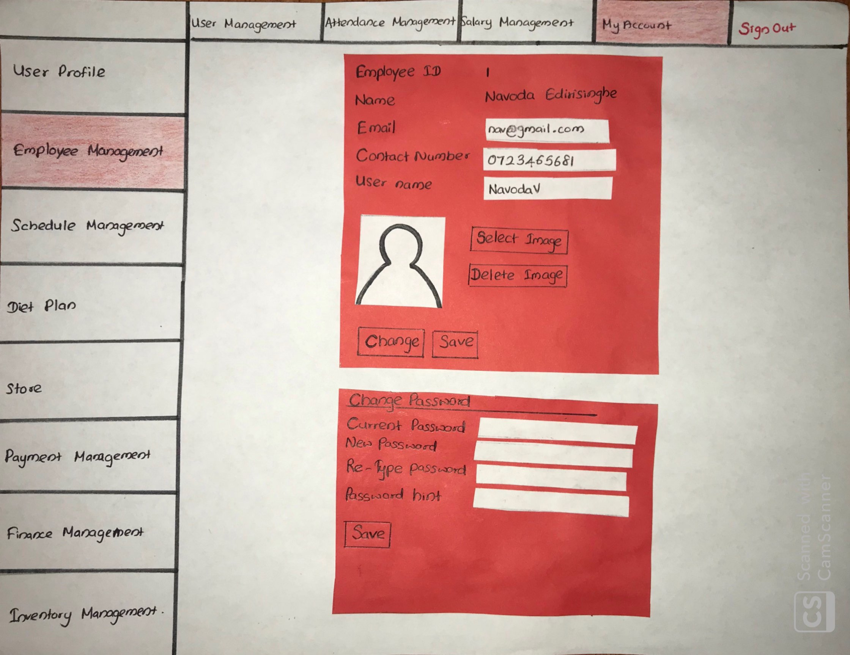

Employee can update limited information (email, contact number, username , image, password etc.) his/her own profile(view).

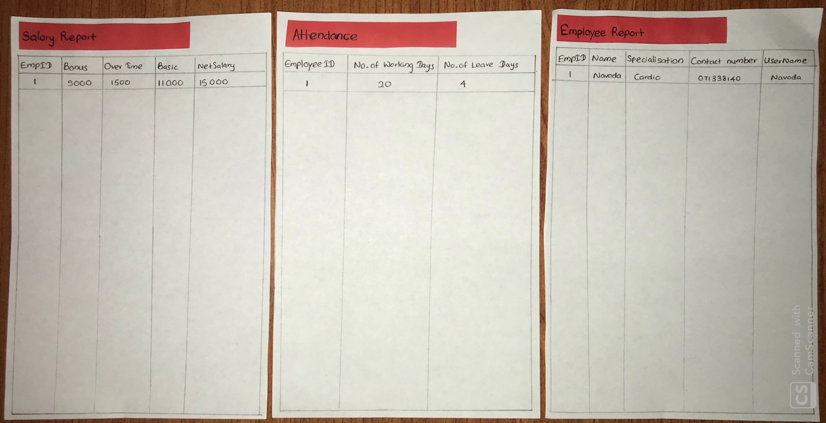

These are the report generated by the employee management.

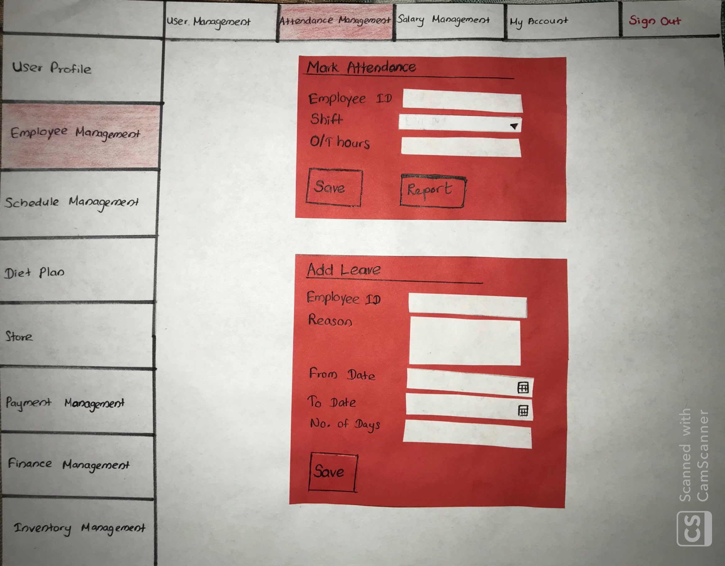

In admin side admin can mark attendance of every Employee. But Trainer cannot mark attendance. In trainer side this mark attendance section is invisible. Both admin and trainer can request a leave by using add leave form. Admin can generate attendance report.

**Schedule Management**

**Krishnamoorthy.N**

**IT18144772**

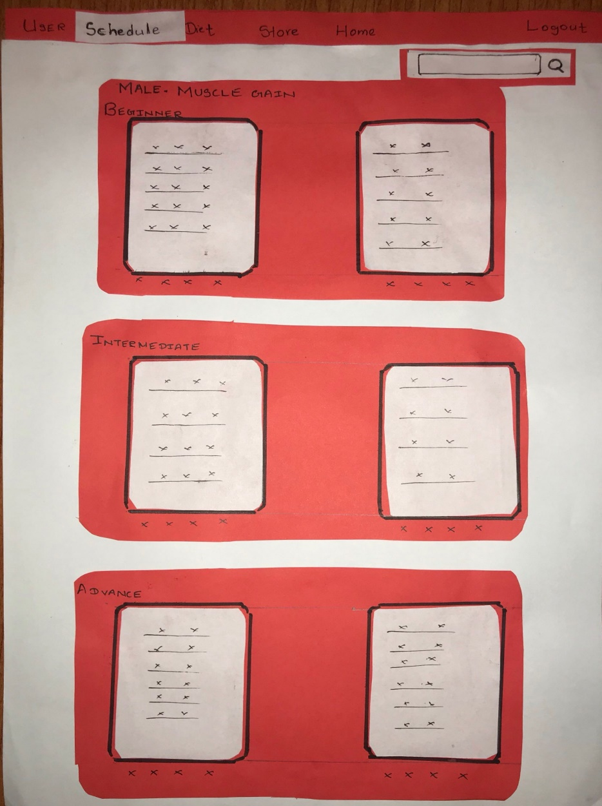

Under this UI we are suggested with schedule types According to the **Gender** of the Member and the **Category** he/she has selected when signing up with the system. The level of schedules suggested are

* Beginner
* Intermediate
* Advance

When customer selects a schedule he will be assigned with the selected schedule as his workout plan.

If the customer completes his/her schedule the customer is suggested to select the same schedule or change the schedule. When changing the schedule the Same UI is displayed according to the selected category by the a member.

Along side this page there is a search bar in which we can search the schedules.

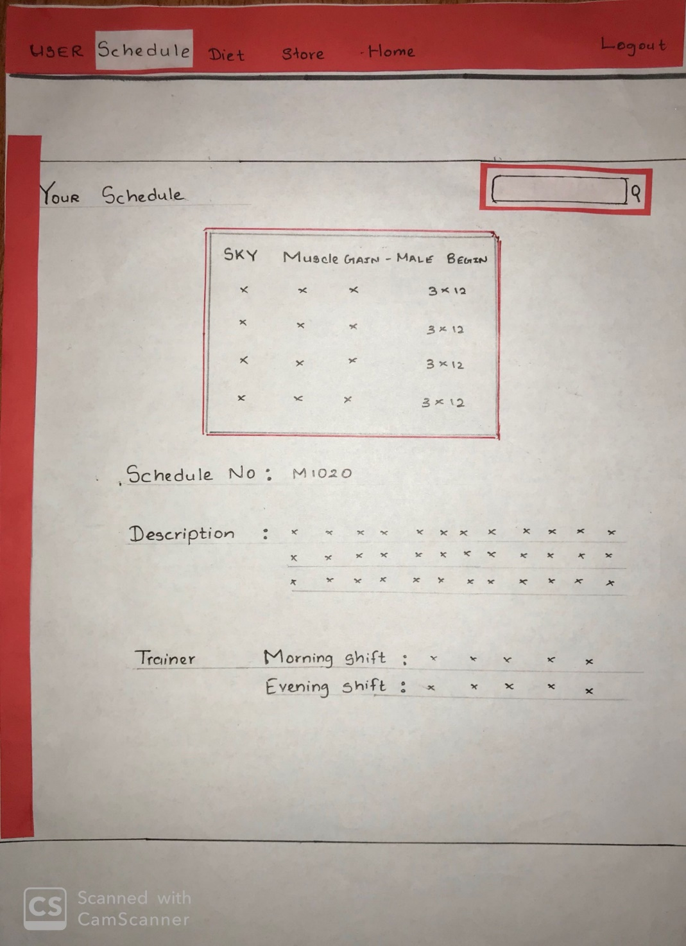

After selecting a schedule if the customer visits this page using the schedule tab he will be informed with the selected schedule. It has all the necessary information about the schedule.

Along side this page there is a search bar in which we can search the schedules.

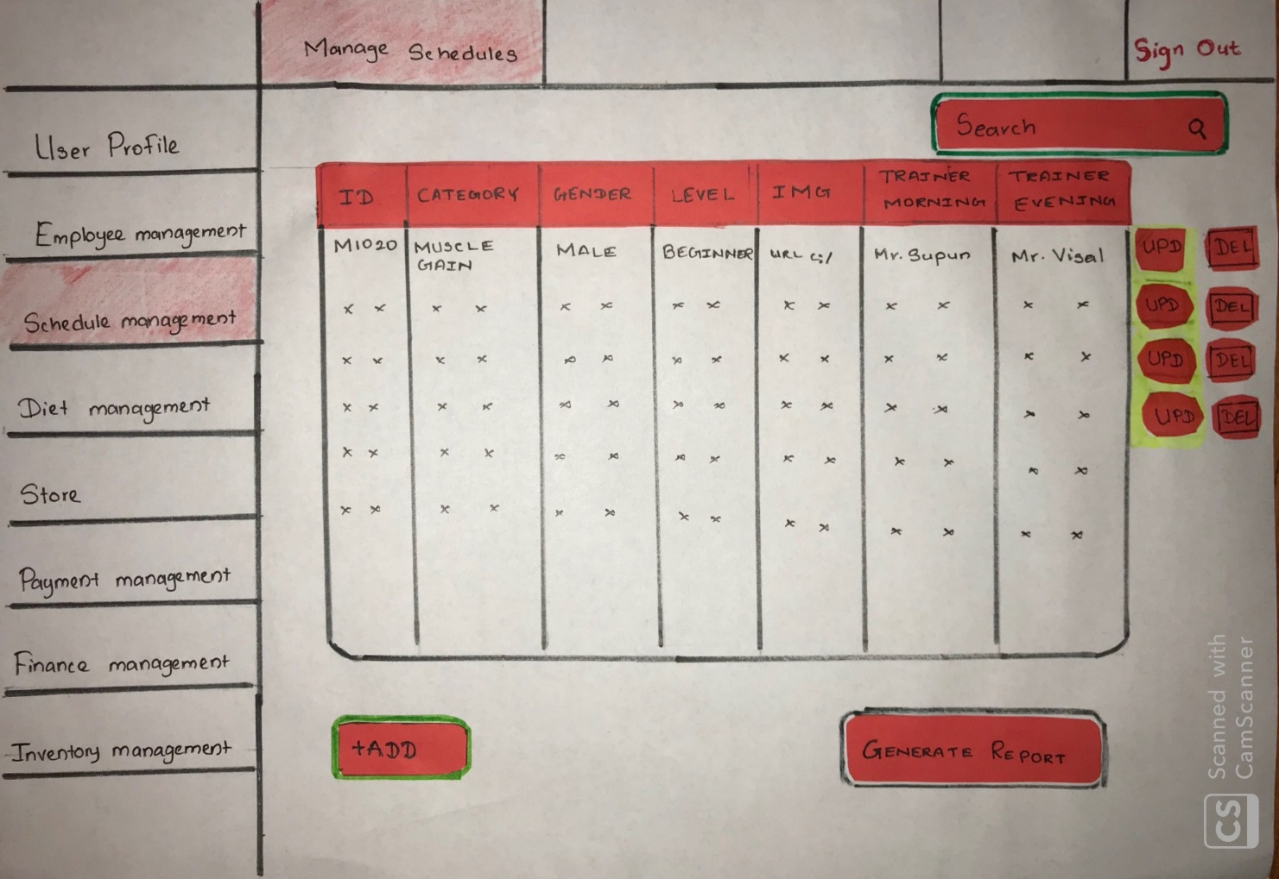

This page Belongs to The Admin Side this page contains all the related task for CRUD functionality.

It consists with a search bar which is capable of searching the schedules and the searched items will be displayed in the table.

Every single item has a **update** and a **delete** button.

If we delete a schedule which is being used by a member the system will prompt a warning message.

At the bottom of the page we are provided with the **Add** button which is suitable for adding new functions.

The page also contain a Generate Report which will generate an overall schedule report.

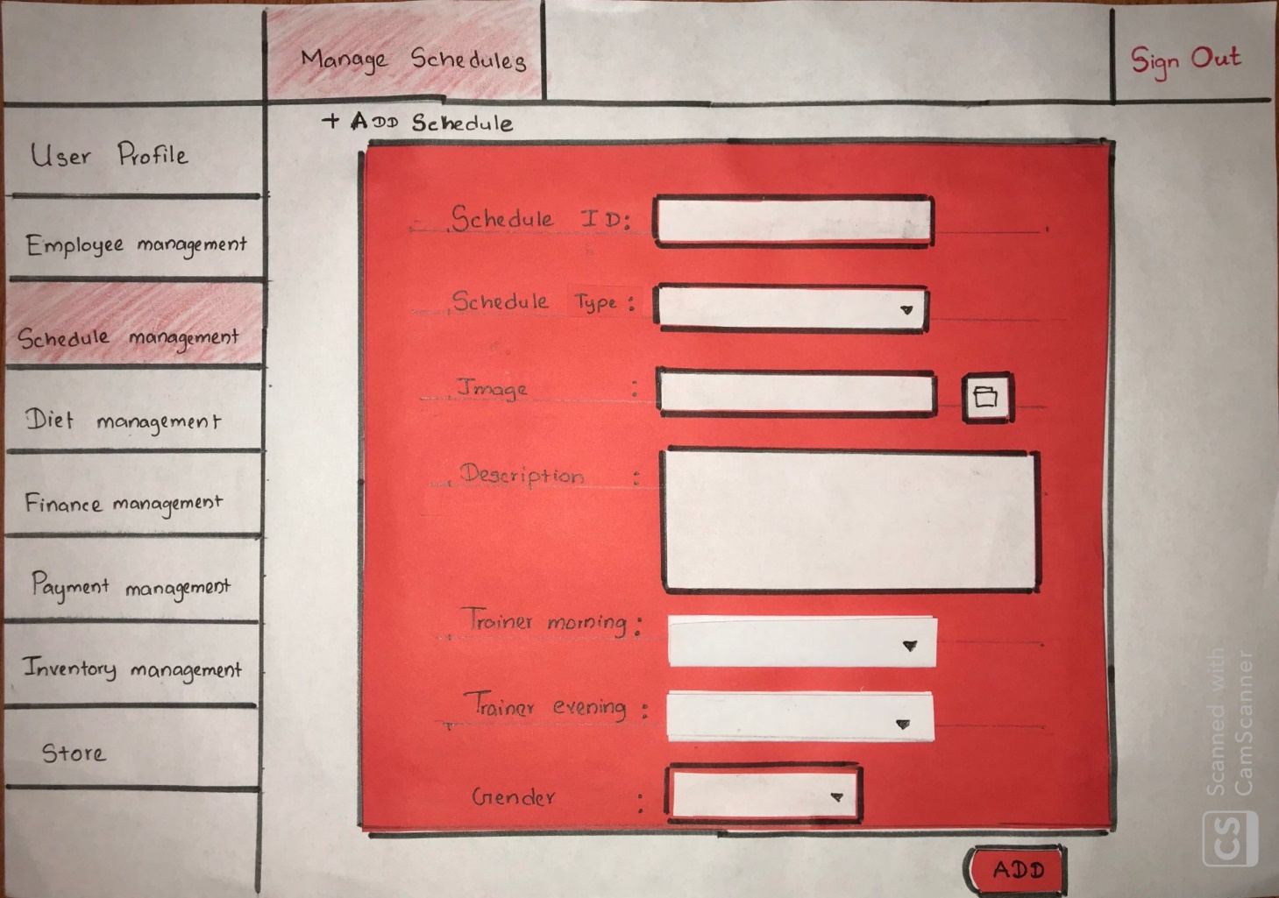

This UI belongs to the page which is used to Add a new Schedule to the system. This contains a form

with required credentials with proper validation. After pressing Add button the Admin can add a new schedule on the required category using the credentials.

The same page is displayed when Updating the schedule where the Add button changes to Update in which we can update the required schedule with the required field.

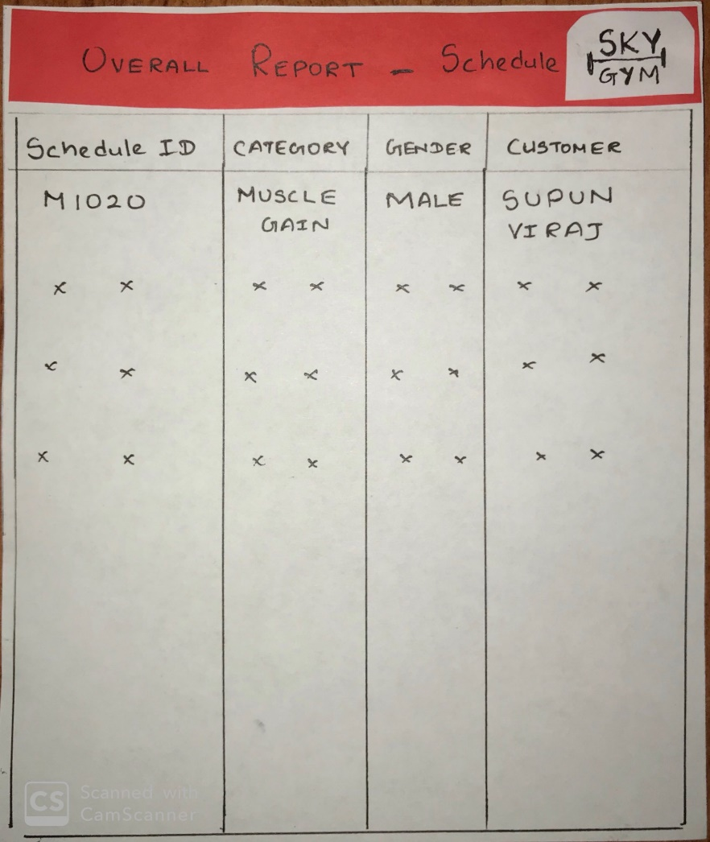

This is the Overall Report that is generated with the use of the system which can be printed afterwards.

This Report is generated using the Database which stores the schedules.

The Report contains information such as Schedule ID, Category, Gender and the Name of the member using that particular schedule.

**Diet Plan Management**

**Jayasooriya D.C.**

**IT18118650**

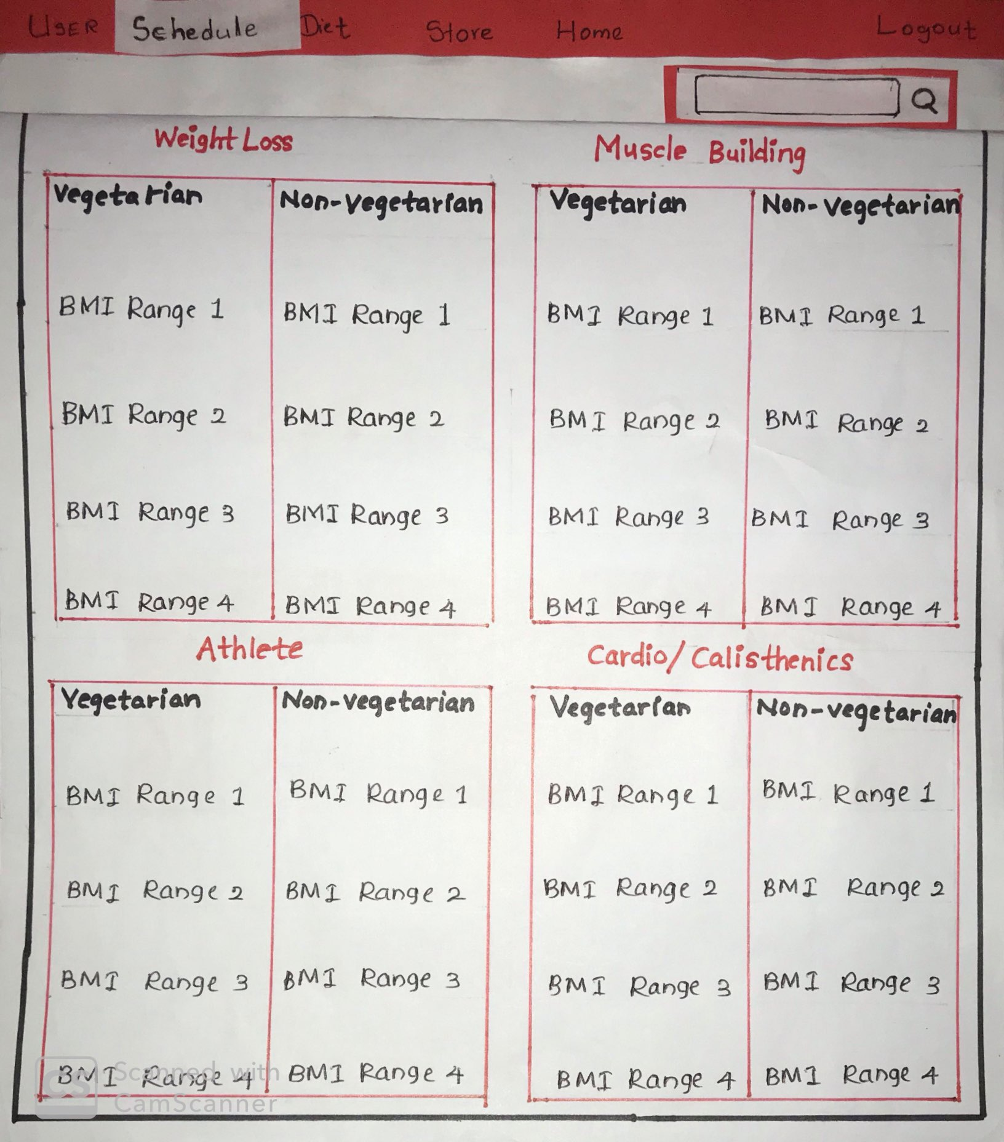

When user log in to the system, user can enter to the diet plans page. There will be able to pick a diet plan according to his/her BMI. System will suggest diet plans to the member in a various BMI range. Not only that these diet plans are categorized as Vegetarian and non-vegetarian. When user enter to this page Age, Weight and Height are auto generated.

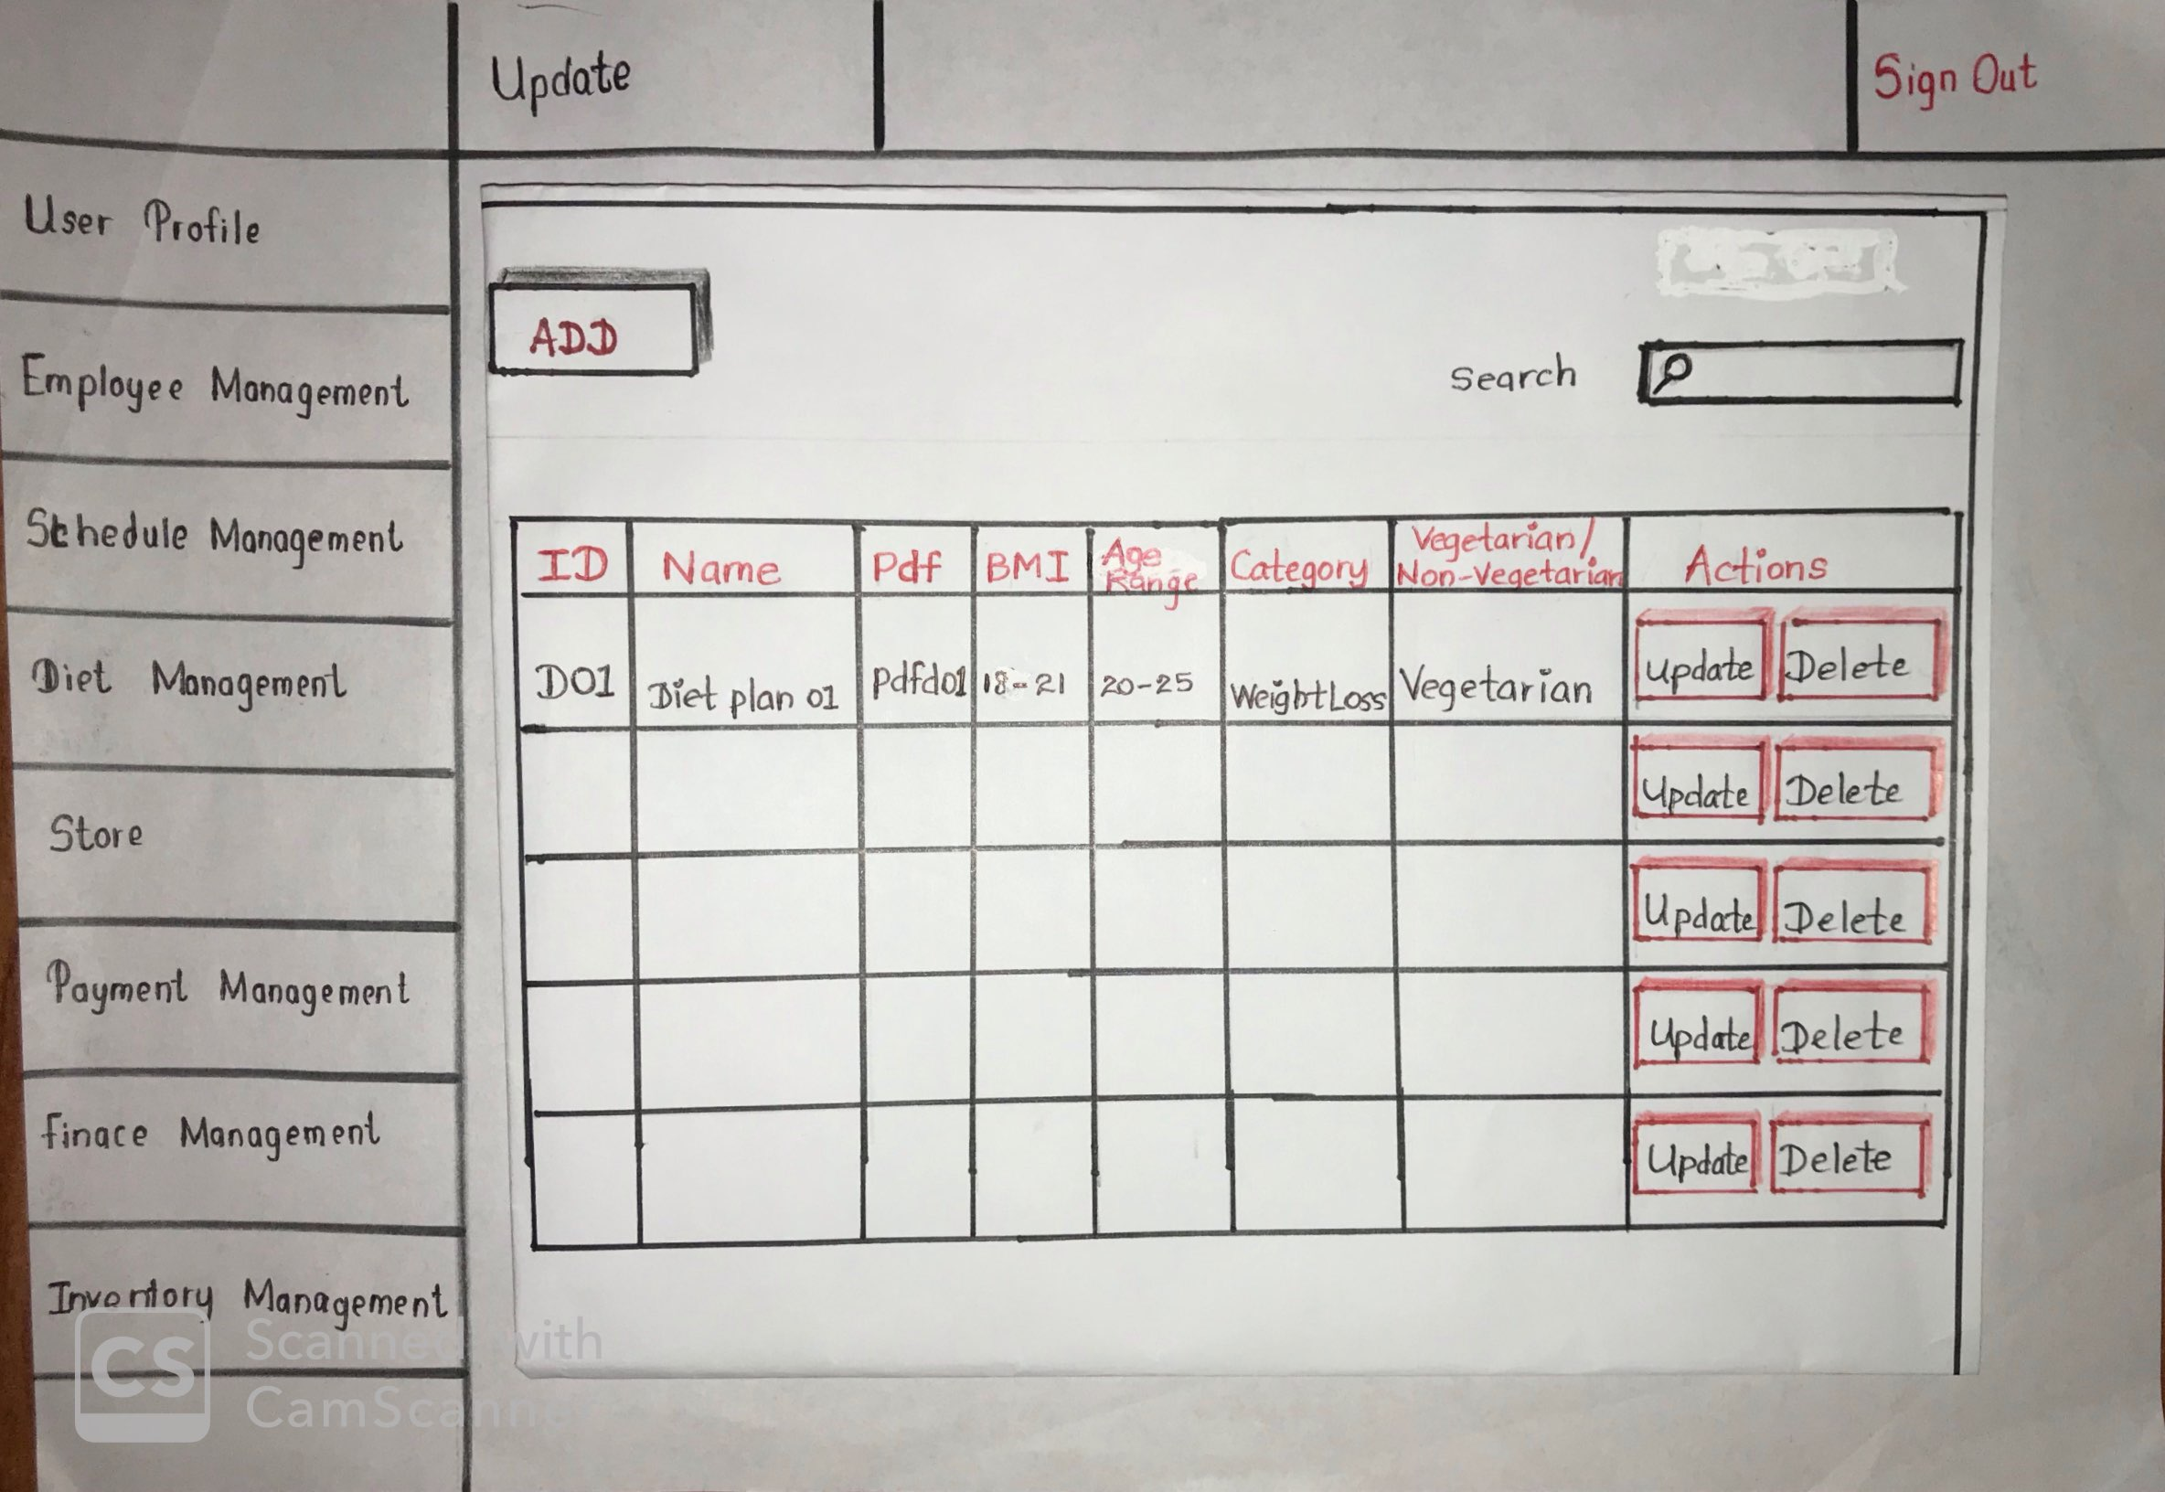

The admin can add new diet plans, update and delete diet plans for the members to use. The administrator can also search for a particular diet plan using the name of the diet plan or the diet plan ID.

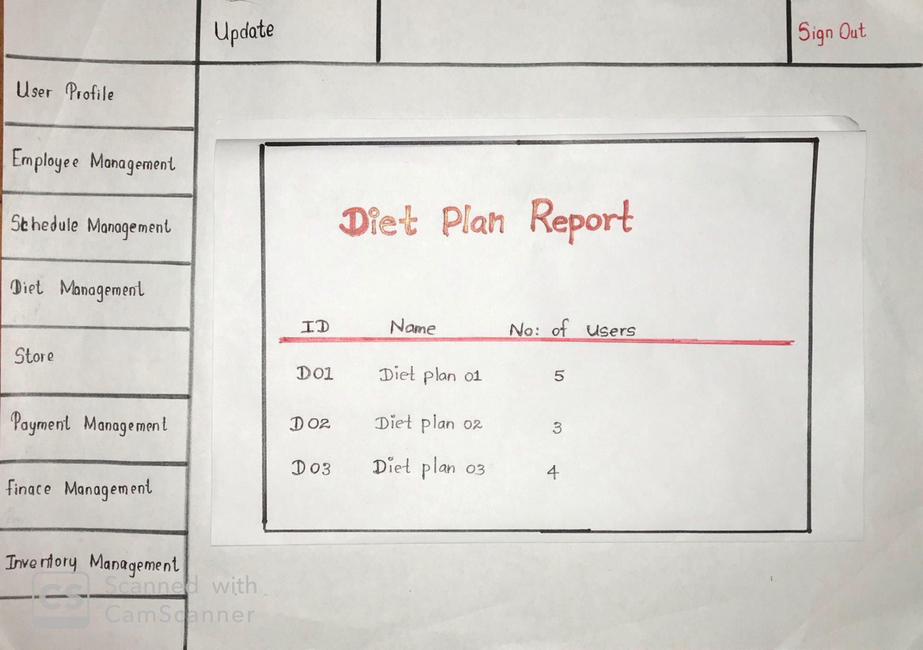

The Admistratpor can generate reports as shown above.

**Store Management**

**Sangeeth Raj .A**

**IT18152074**

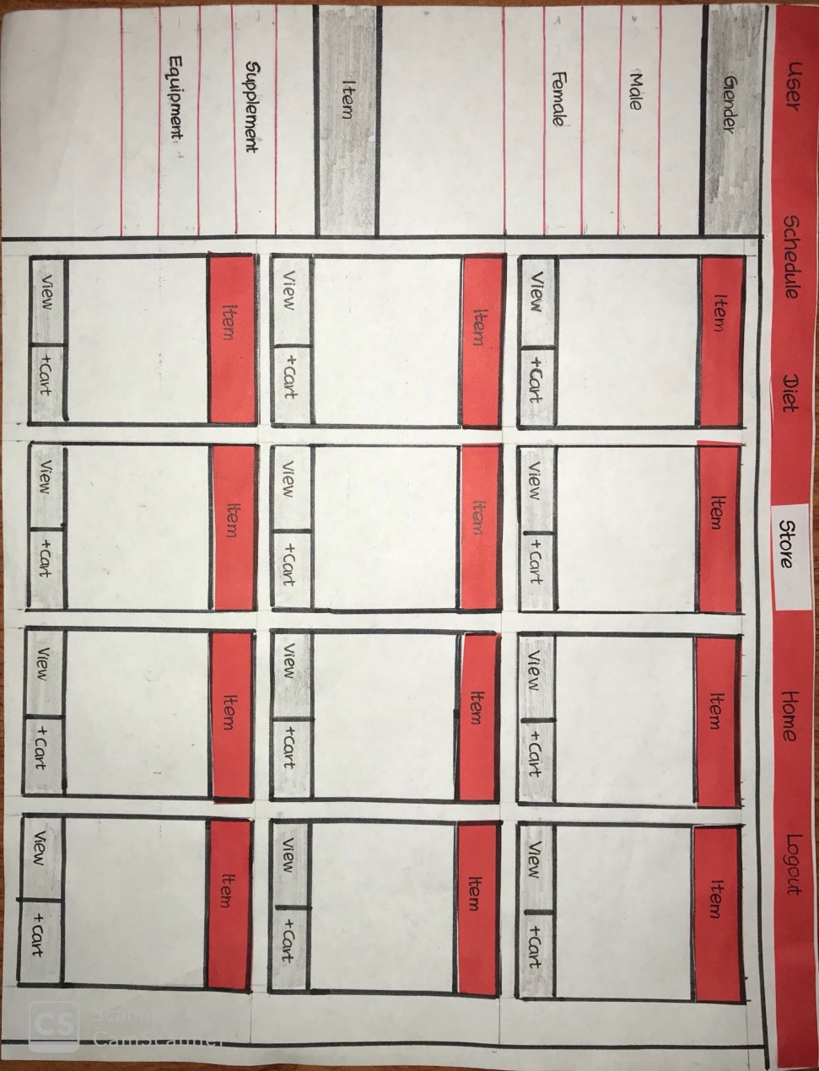

The UI of the store is designed based on user friendliness. It displays the items available in the inventory which are allocated to the online store. In the displayed items users can view item details by pressing the “VIEW” button and can add the item to the cart by pressing the “ + CART” button. We have sorted out the items in the store in two main categories as Gender and Items respectively with two sub categories for each Male and Female, Supplement and Equipment.

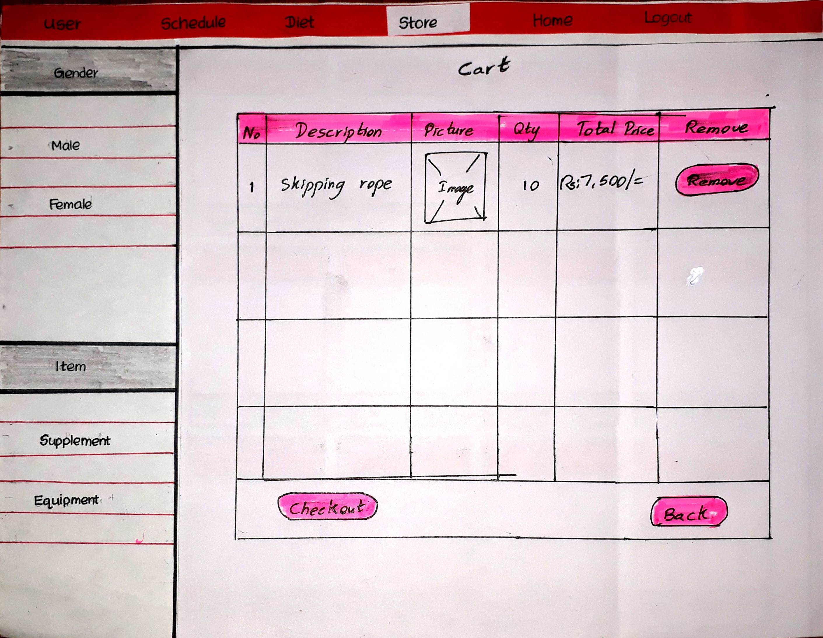

The online store cart is designed as the usual cart with the item selected with the default price and quantity for one product. The users can increase or decrease the quantity of the items to be purchase so that the total price will be increased parallely. The user can also remove items from the cart if the wish to remove by pressing “REMOVE” button. And finally the user can check out the items to purchase by clicking the “CHECKOUT” button.

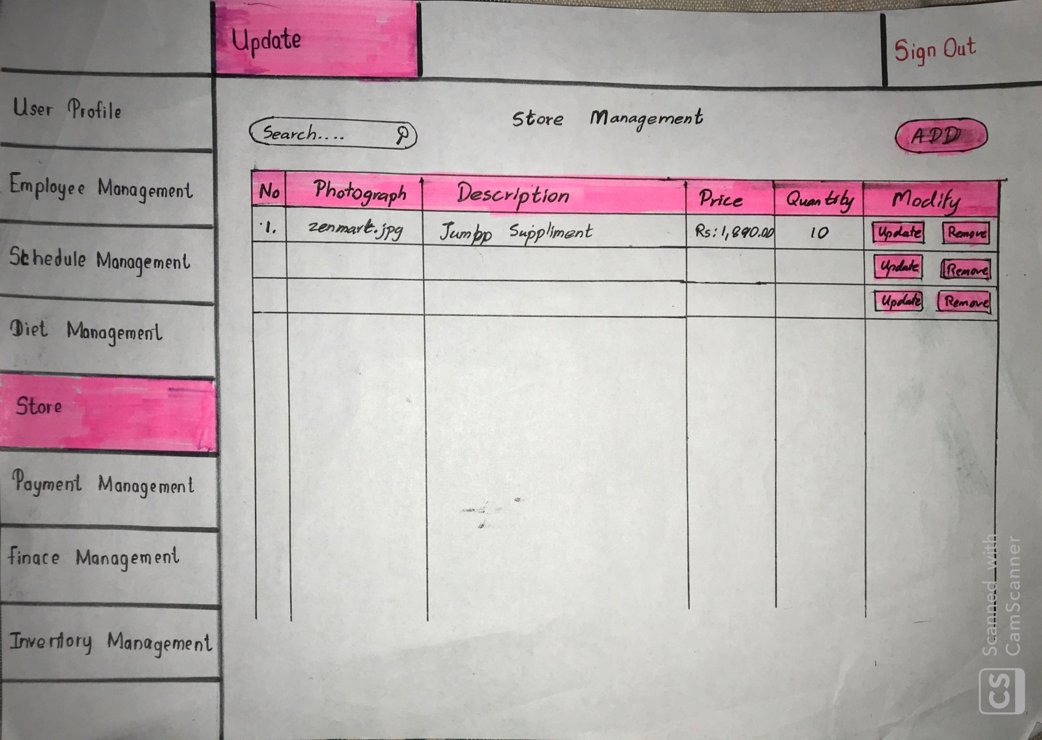

In the store management the admin can is able to add items to the online store from the items available in the inventory using the “ADD” button and can remove items using “REMOVE” button. Admin can update the description, price, quantity, photo of the item using the “UPDATE” button.

**Payment Management**

**Devduni.R.M.B**

**IT18128932**

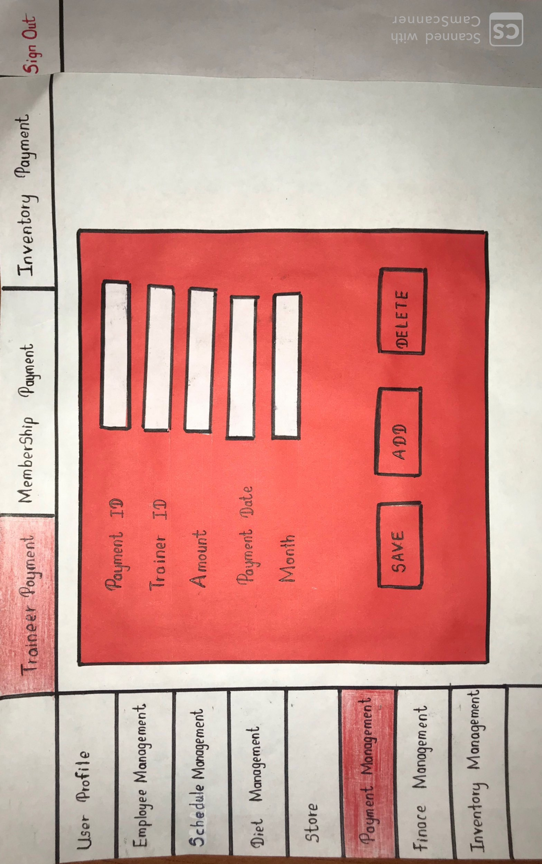

In membership payment there are 3 payment methods to select monthly basic, six months, annual basic. The admin can add, update or remove the exiting schemas. Admin keep track of payment of the members. In membership payment UI admin can search the customer’s payment history detail by giving the customer ID. Also admin can generate reports of the payments made.

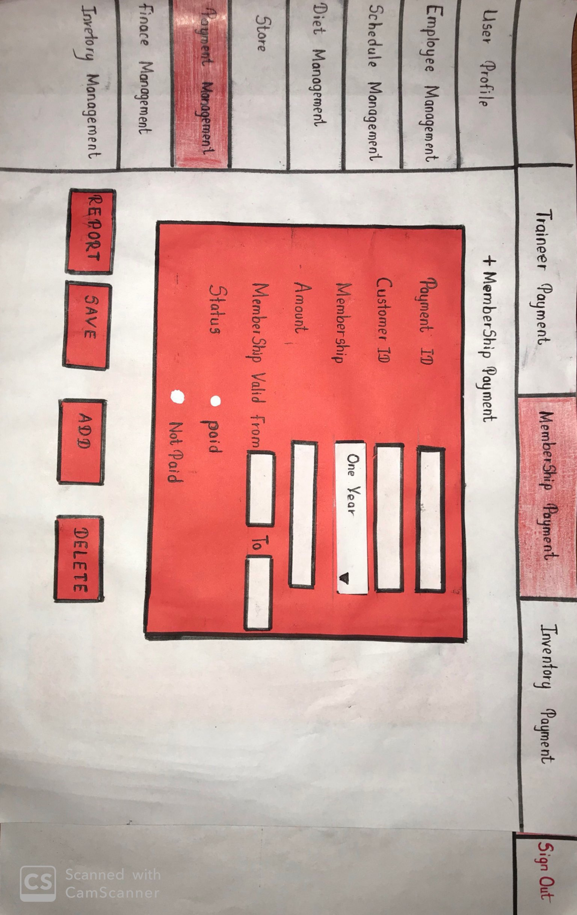

The above interface is for the administrator to add user/member payments to the system.

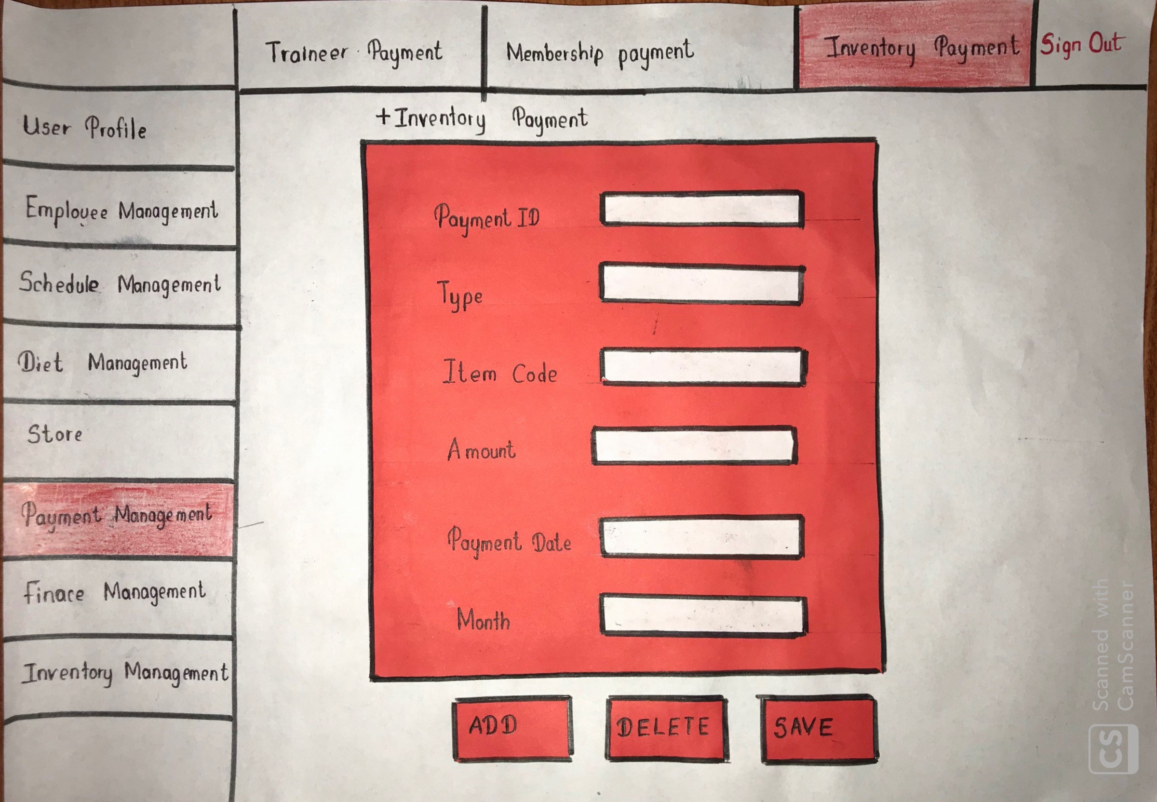

The above interface is to add and delete payments made for inventory of the GYM.

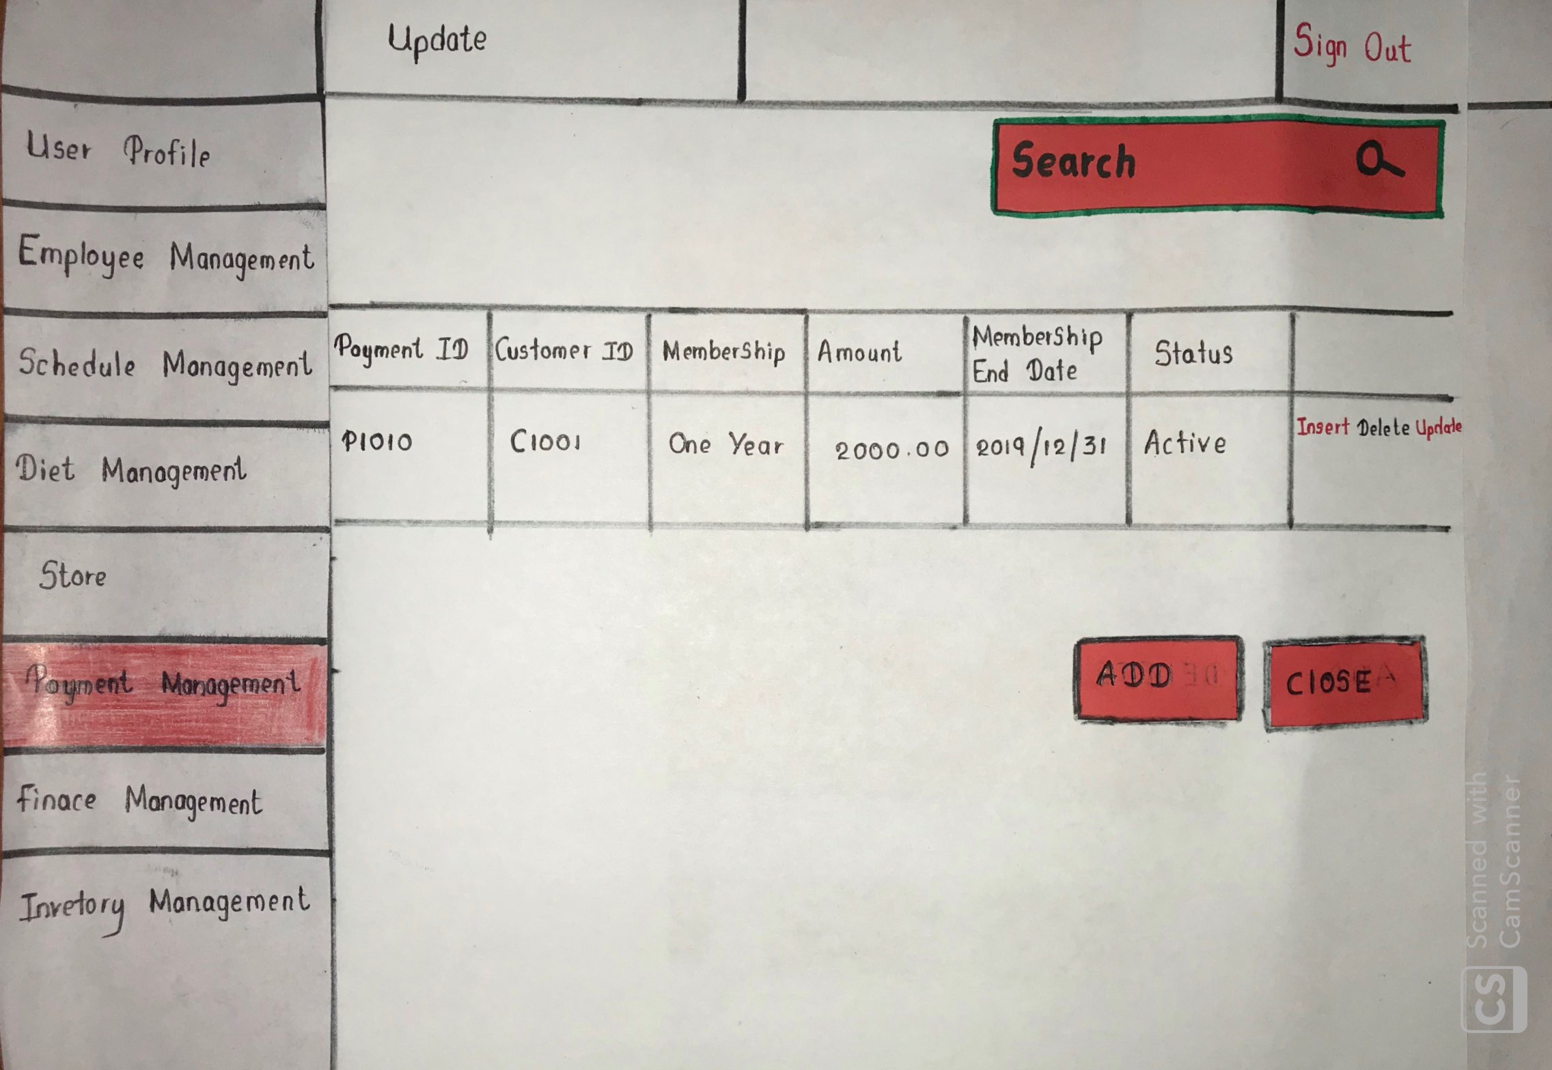

The above interface is to add and delete payments made to the trainers of the GYM.

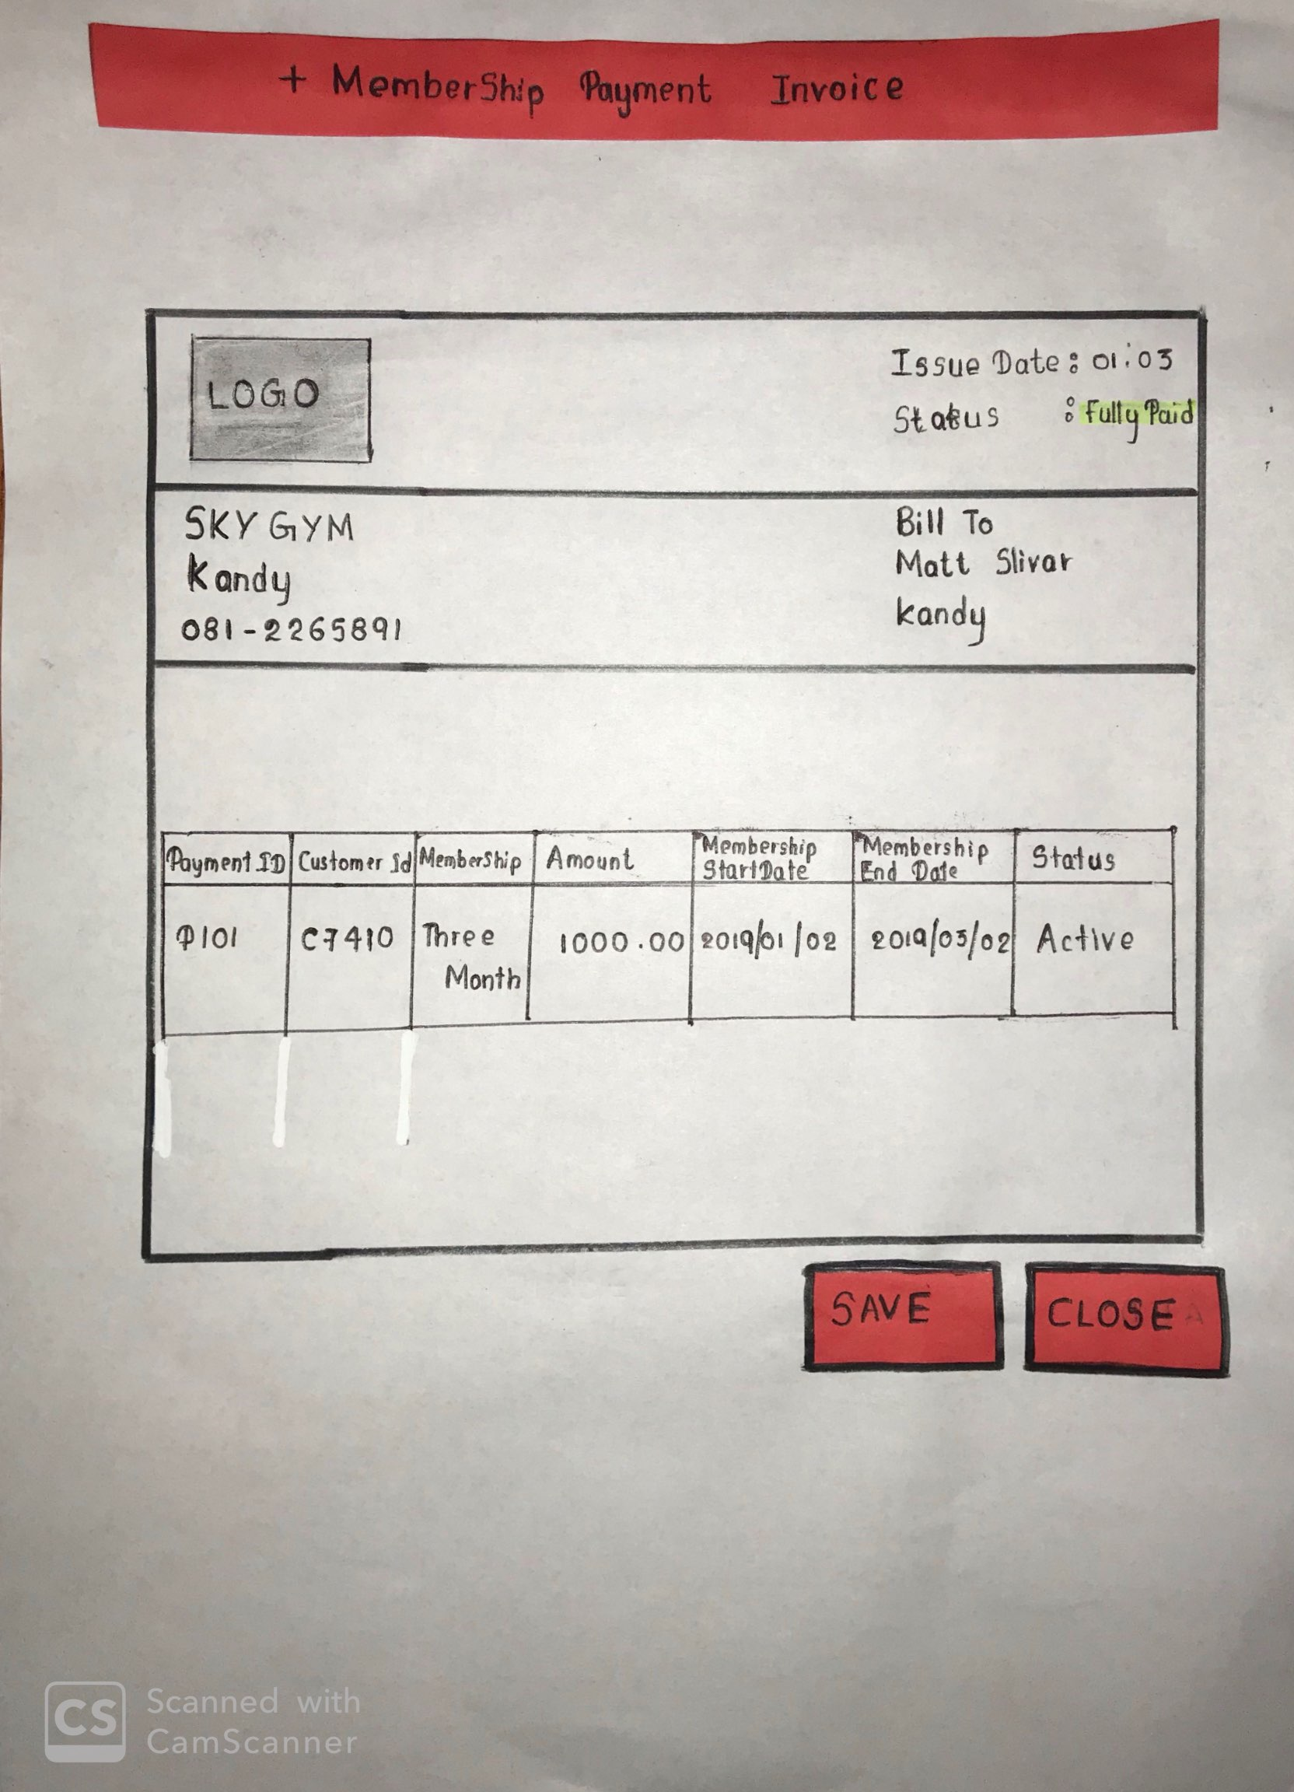

Above is the invoice that will be generated by the system after the member makes a payment.

**Finance Management**

**Imalsha Kavindi K.G.**

**IT18118414**

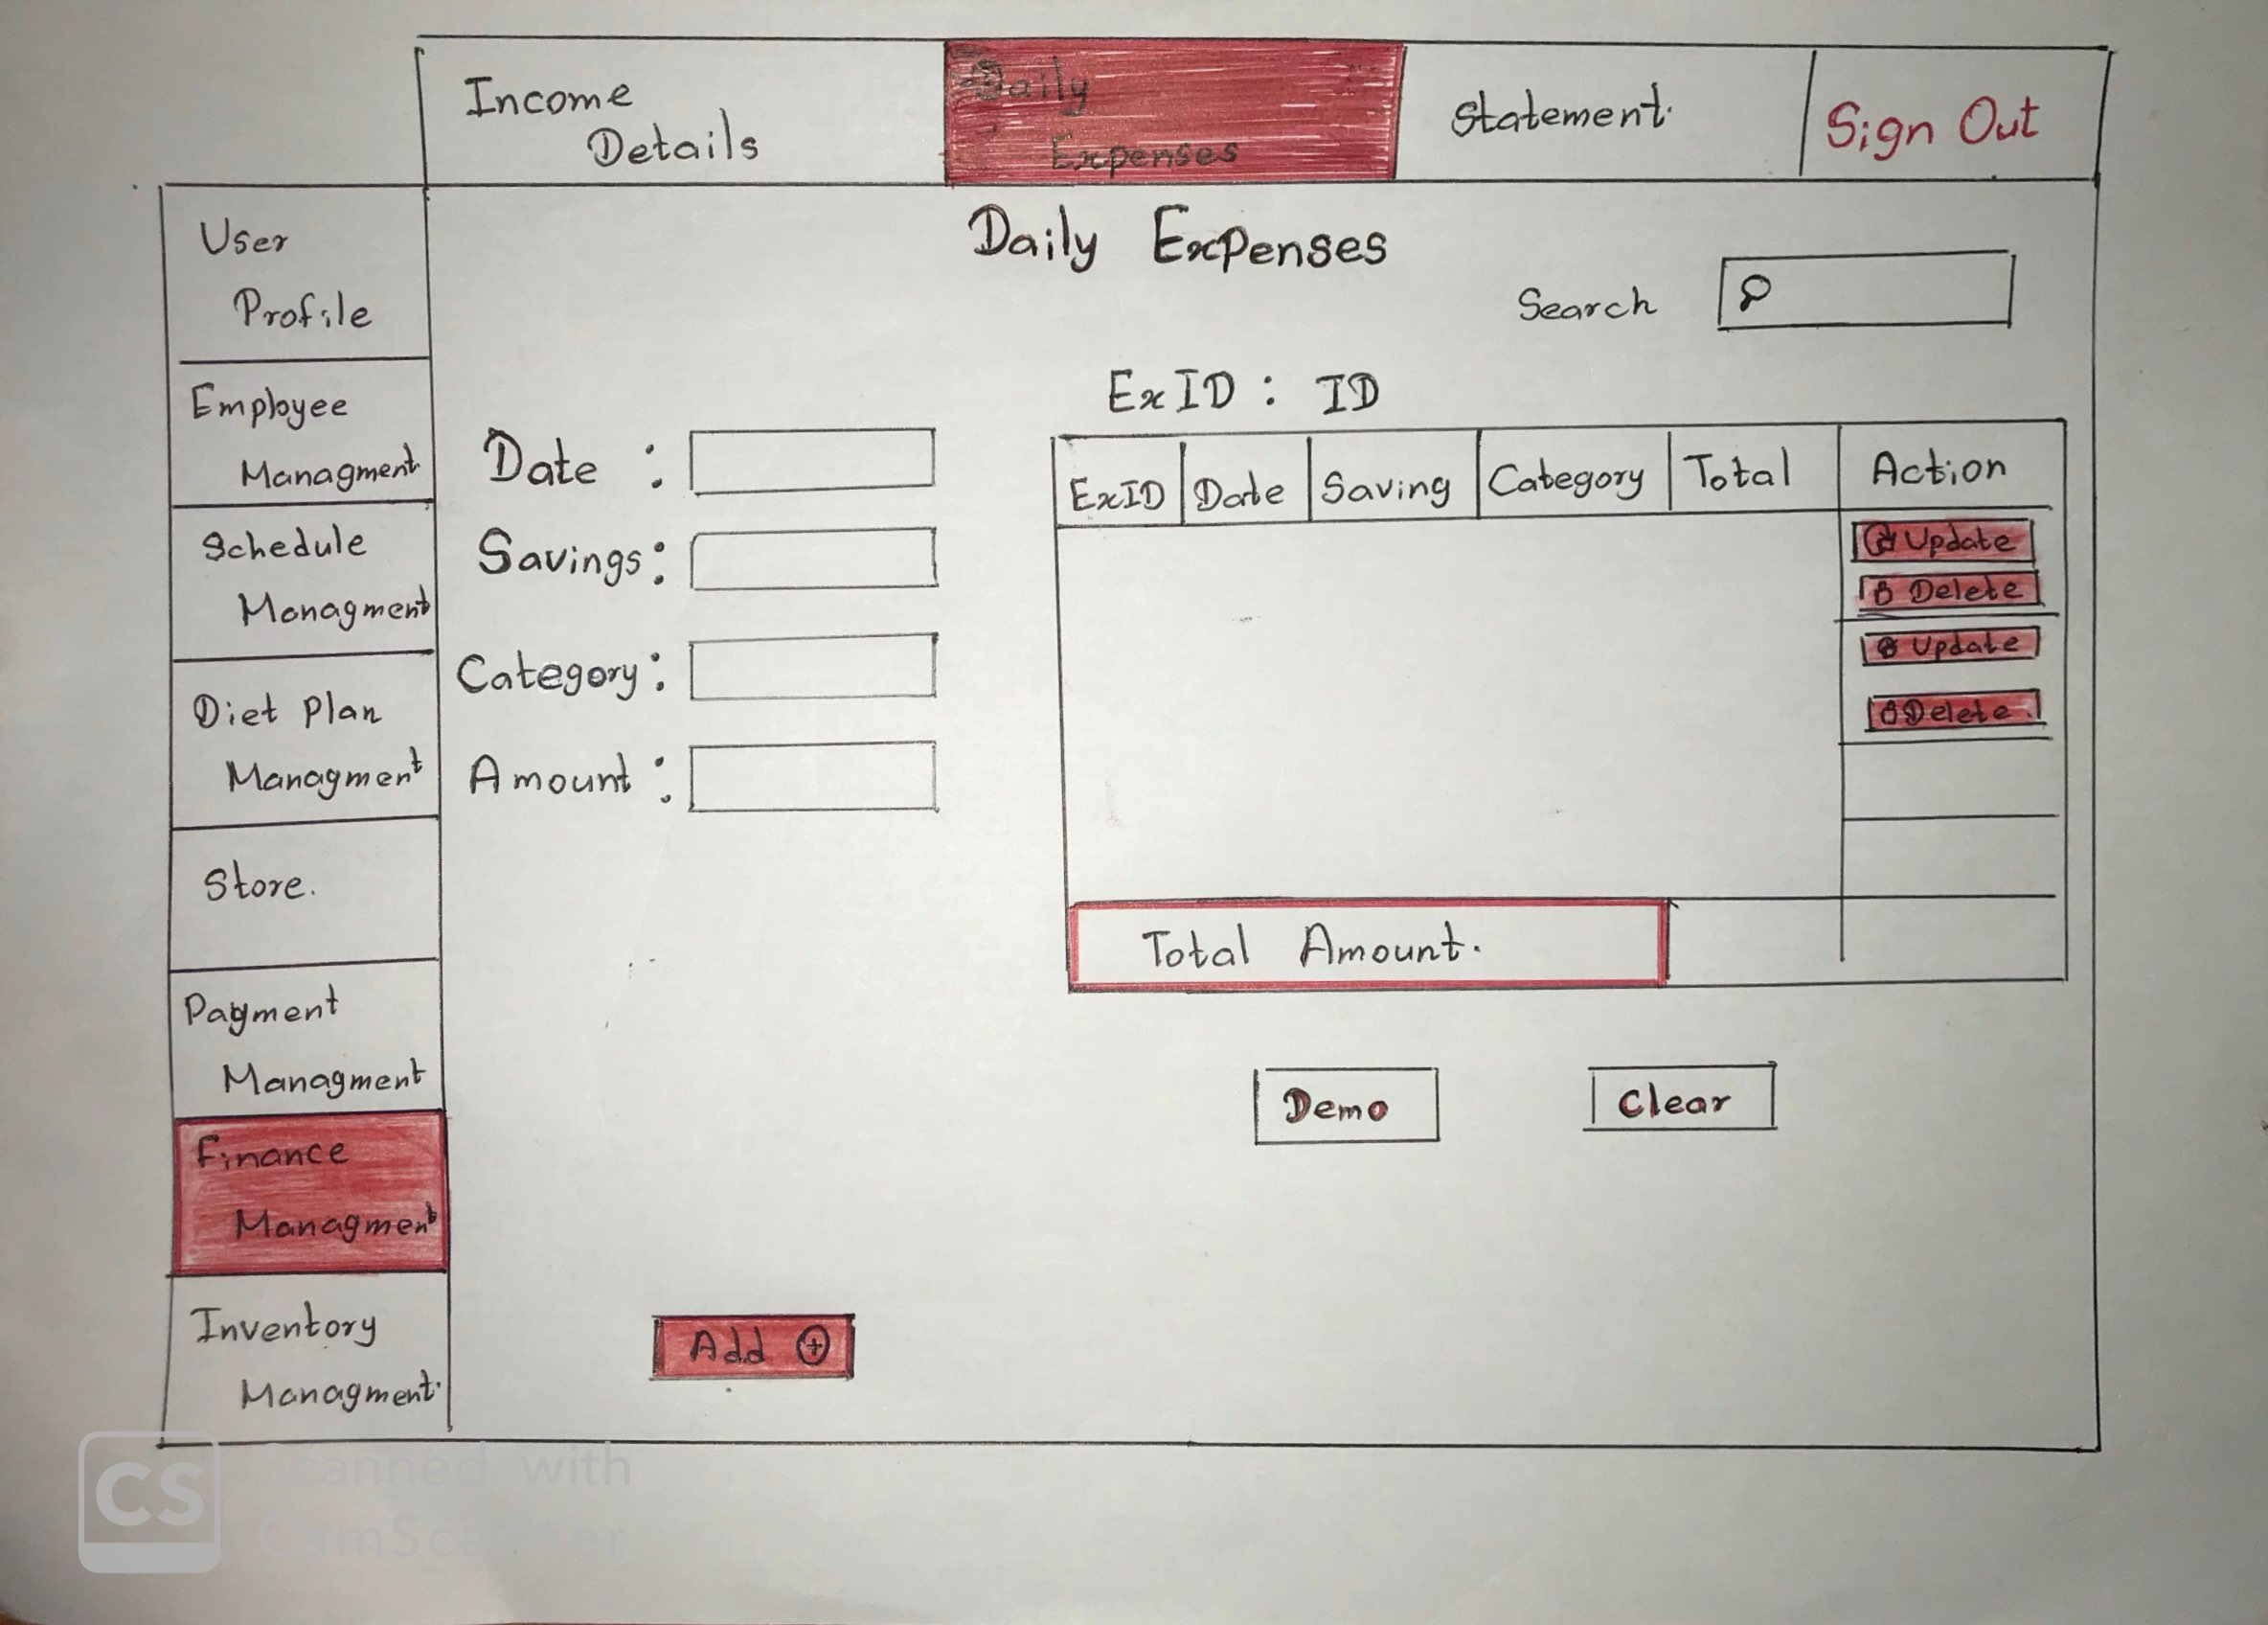

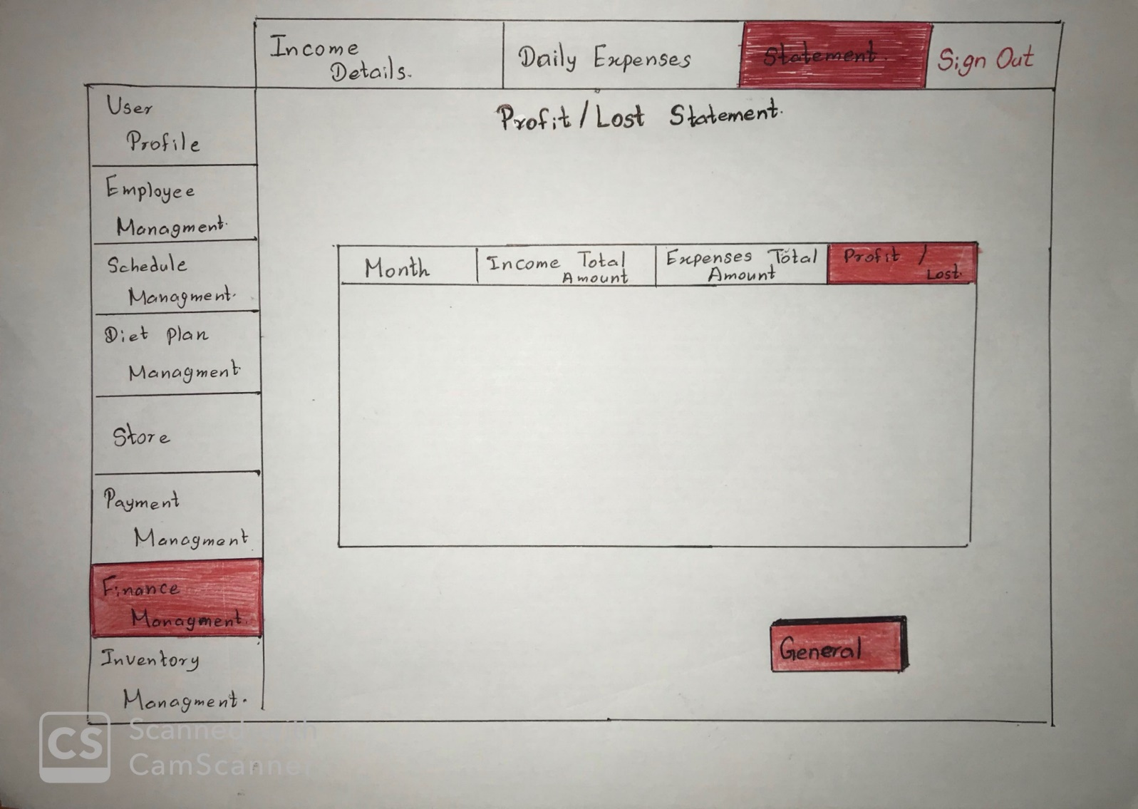

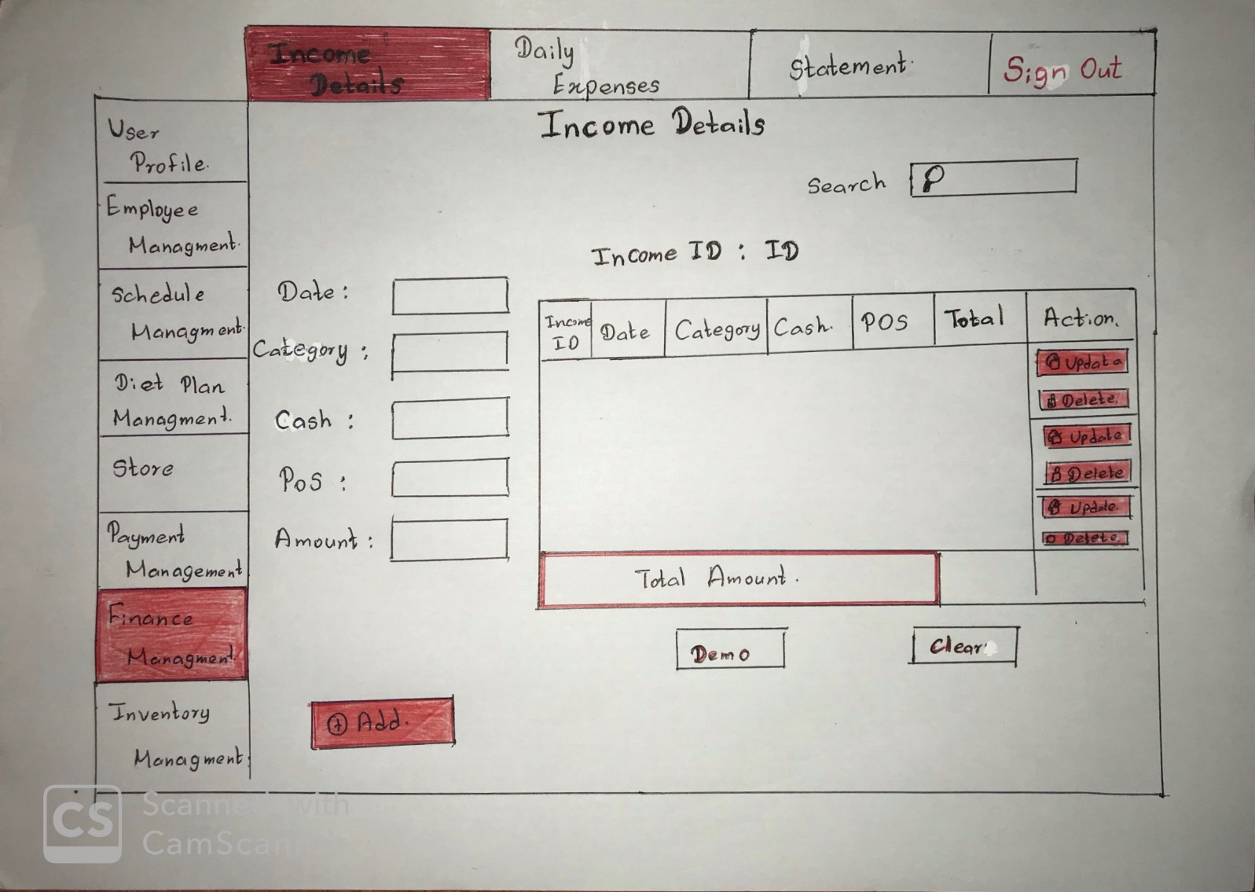

**Inventory Management**

**Z.M.M. Akaam**

**IT18050868**

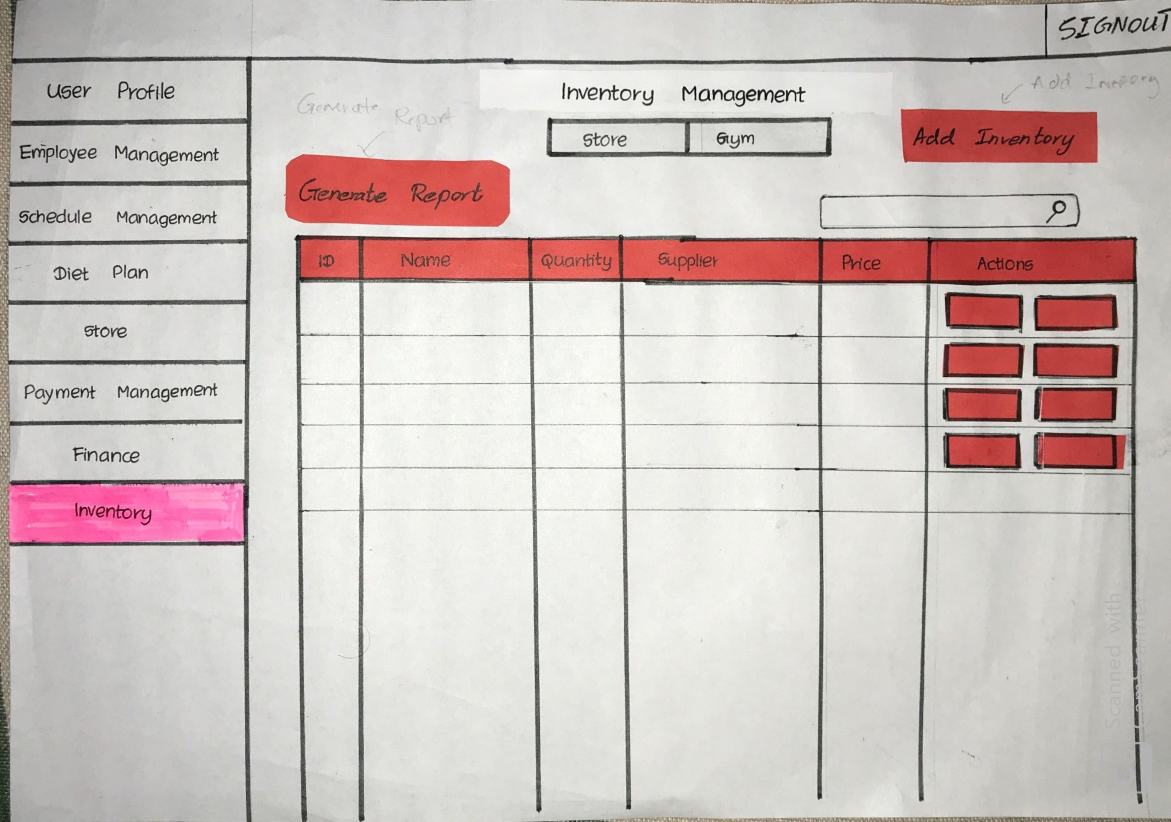

Inventory Management helps the administrator to handle the inventory of the GYM which includes both gym inventory and inventory of the store. The navigation bar at the top helps the administrator to navigate and filter the ‘Gym’ inventory separately and the ‘Store’ inventory separately. The inventory details are displayed in a table. The admin also has the ability to ‘update’ an inventory or to ‘request for maintenance’ for the inventory of the GYM. Where in store inventory the administrator has the ability to ‘Update’ or ‘Reorder’ an inventory. Generate report buttons generates reports of the inventory. In addition to those the search bar at the top helps the administrator to search for a particular inventory using the name or the item code.

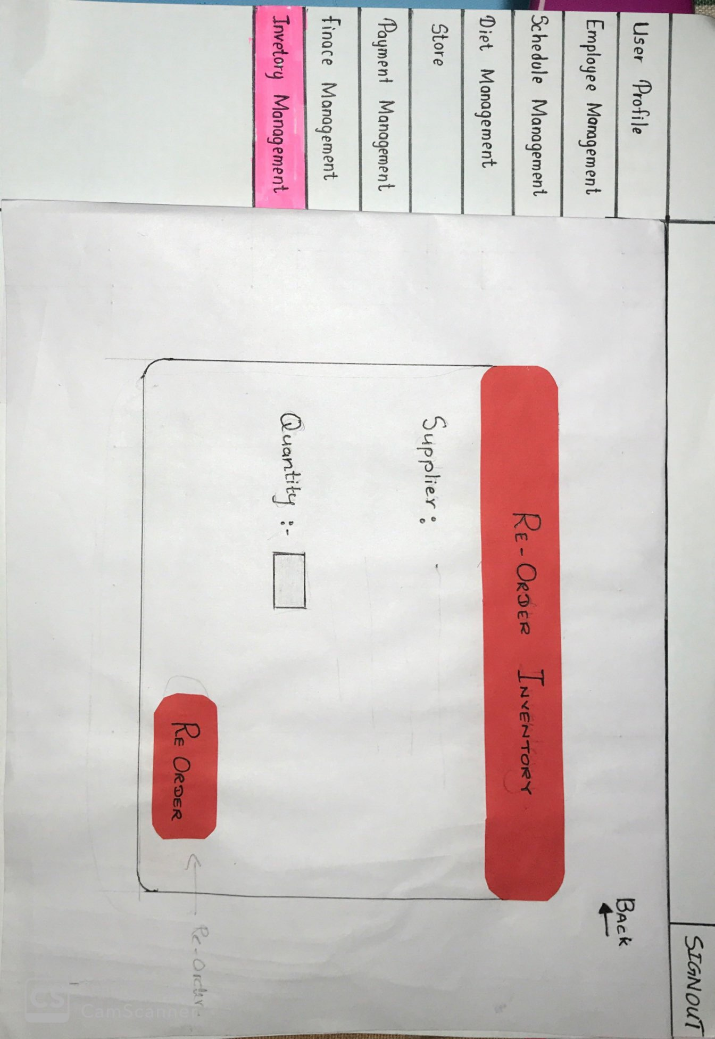

Clicking on the Re-order button on the Store inventory side will navigate to the above page where the item name, supplier details will be specified and the administrator can select the quantity to be re-ordered. Clicking on the Re-order button will send a re-order request to the relevant suppliers. Back button navigates back to the Inventory Management page.

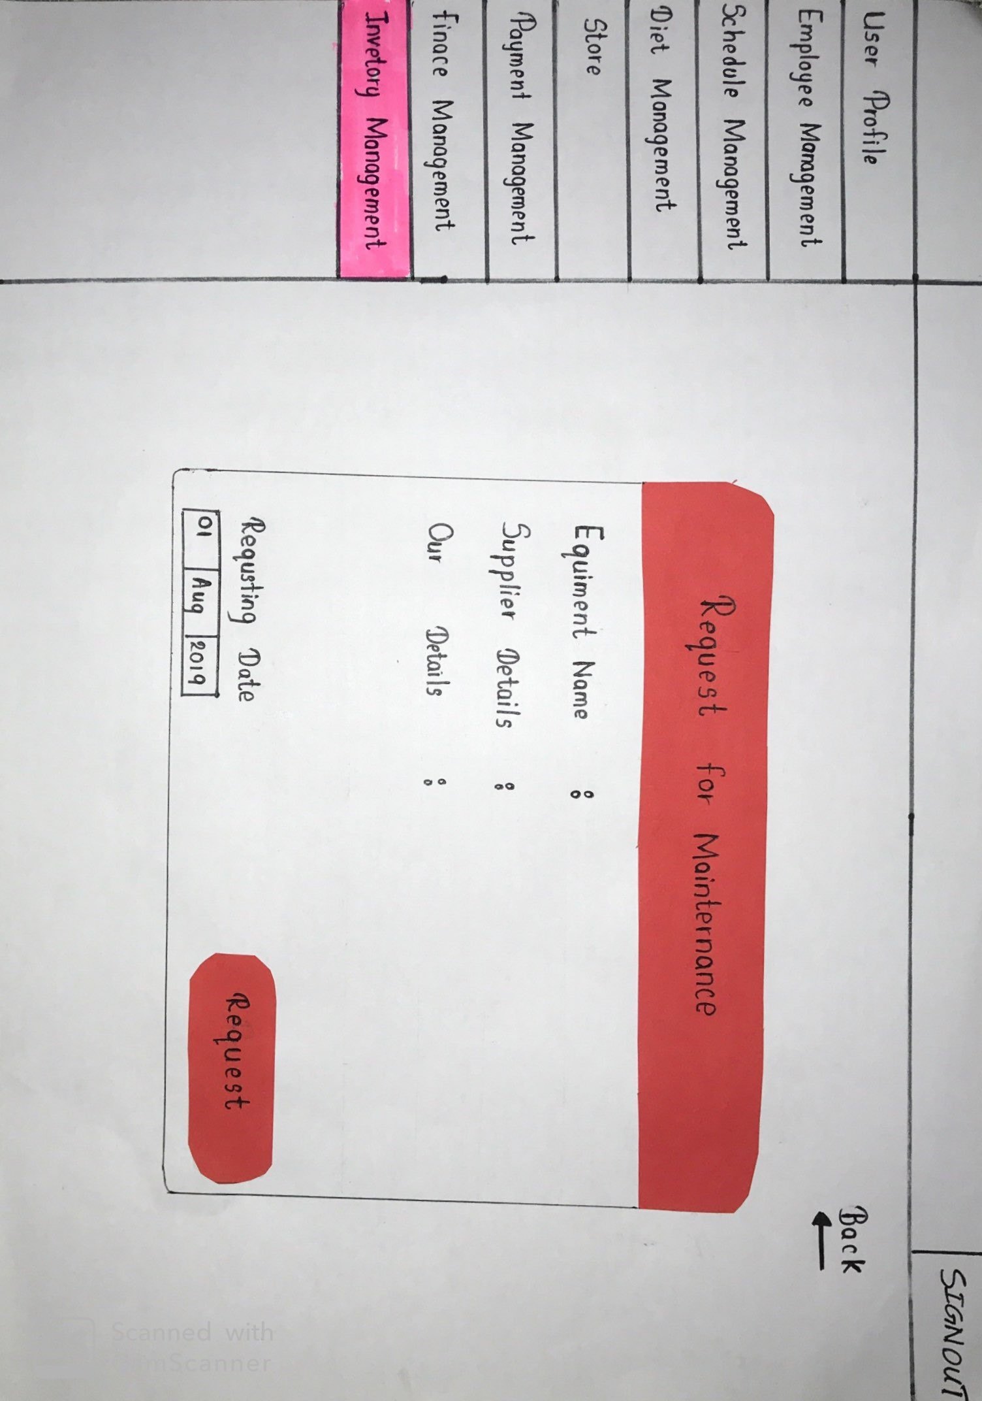

Clicking on the Maintenance button will navigate the administrator to the above page where they will be displayed with the details of the equipment name, supplier, date of request, and our details. A request will be made when the request button is pressed. Back button navigates back to the Inventory Management page.